

“Rule the world with elite.”

CYBER SECURITY

MINOR PROJECT

**Submitted by’**

**Name :-** Yeola Puja Bhagirath

**University :-** MET BHUJBAL KNOWLEDGE CITY, NASHIK

**Year :-** 2023

**Batch :-** July batch

**Submitted to ,**

**Amit Gupta**

**( InternsElite )**

**INDEX**

|  |  |  |
| --- | --- | --- |
| Serial  No. | Project Name | Page  No. |
| 1] | USE NMAP TOOL FOR FINDING INFO. INSIDE THE NETWORK. | 3-15 |
| 2] | WRITE AND EXPLAIN COMMANDS IN WINDOWS COMMAND PROMPT FOR NETWORK /SERVER DETAILS | 16-23 |
| 3] | USE WEBSITE COPYING TOOL FOR WEBSITE COPY(HT-TRACK). | 24-27 |
| 4] | USE WIRESHARK TOOL FOR PACKET CAPTURING. | 28-35 |
| 5] | TOOLS FOR FINDING DETAILS OF ANY NETWORK OR SERVER/WEBSITE (IP LOOKUP WEBSITE). | 36-47 |

**1] USE NMAP TOOL FOR FINDING INFO. INSIDE THE NETWORK**.

NMAP - (Network Mapper) is an open-source network scanning and exploration tool. It's designed to discover hosts and services on a computer network, thus creating a "map" of the network's structure. Nmap operates by sending specially crafted packets to the target hosts and analyzing the responses it receives. This allows it to determine which hosts are online, what services are running, and various characteristics of the network.

Nmap is highly versatile and offers a wide range of scan types, from basic host discovery to more advanced techniques such as port scanning, service version detection, operating system fingerprinting, and even running custom scripts against target hosts. It's widely used by network administrators, security professionals, and ethical hackers to assess the security of networks, identify potential vulnerabilities, and troubleshoot network issues.

**Features of Nmap :**

* Ability to quickly recognize all the devices including servers, routers, switches, mobile devices, etc on single or multiple networks.
* Helps identify services running on a system including web servers, DNS servers, and other common applications. Nmap can also detect application versions with reasonable accuracy to help detect existing vulnerabilities.
* Nmap can find information about the operating system running on devices. It can provide detailed information like OS versions, making it easier to plan additional approaches during penetration testing.
* During security auditing and vulnerability scanning, you can use Nmap to attack systems using existing scripts from the Nmap Scripting Engine.
* Nmap has a graphical user interface called Zenmap. It helps you develop visual mappings of a network for better usability and reporting.

**COMMANDS:-**

**Basic scans**

Scanning the list of active devices on a network is the first step in network mapping.

There are two types of scans you can use for that:

* **Ping scan :**

Scans the list of devices up and running on a given subnet.

* 1. > nmap -sp 192.168.1.1/24
  2. nmap -sn targetIP

A ping scan, also known as a "Ping Sweep," is a basic host discovery technique used to determine which hosts are online in a network.

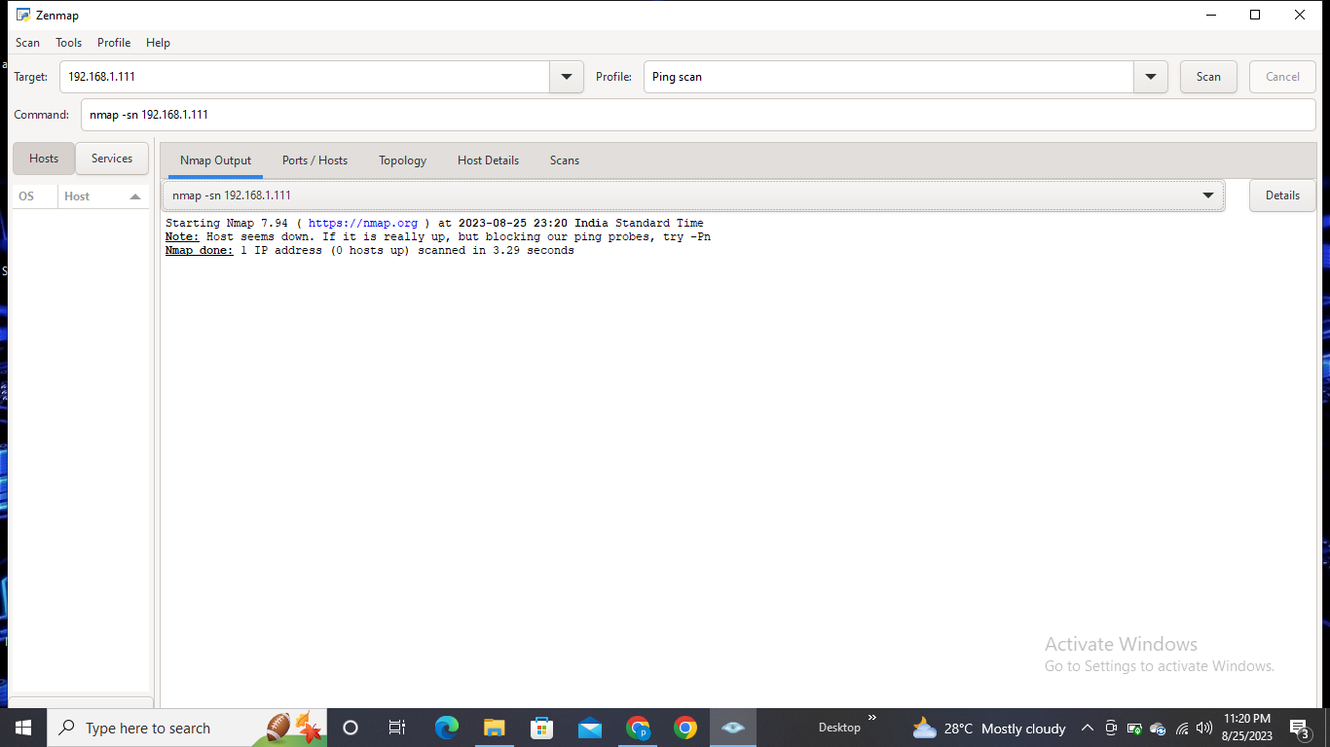

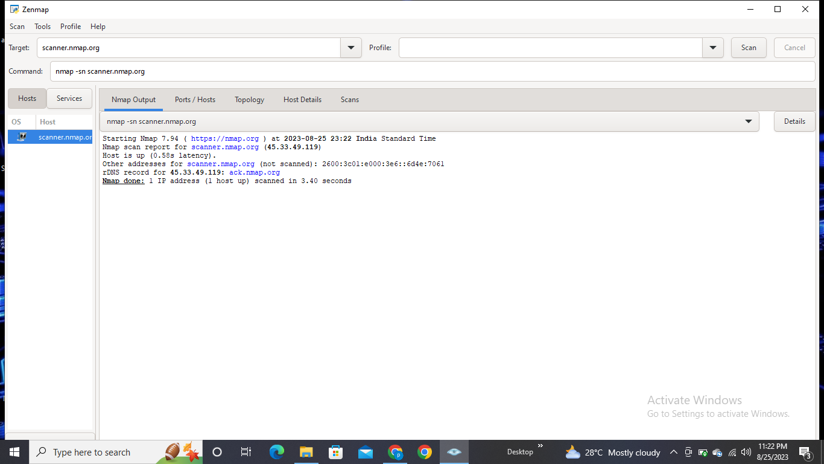

* **Scan a single host :**

Scans a single host for 1000 well-known ports. These ports are the ones used by popular services like SQL, SNTP, apache, and others.

1)> nmap scanme.nmap.org

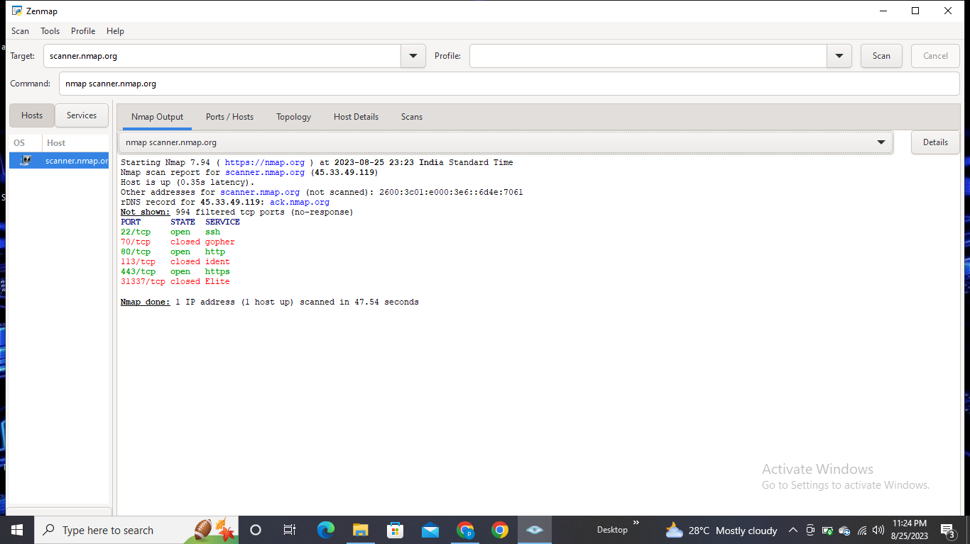

* **Stealth scan:**

A "Stealth Scan" typically refers to a type of port scanning technique that attempts to avoid detection by intrusion detection systems (IDS) or firewalls. One of the most common stealth scan methods is the TCP SYN scan, often referred to as a "Half-Open" or "Stealth" scan.In a TCP SYN scan, Nmap sends SYN packets to the target ports. If the port is open, the target's system will respond with a SYN-ACK packet.

Here's the command for performing a TCP SYN scan in Nmap:

nmap -sS targetIP

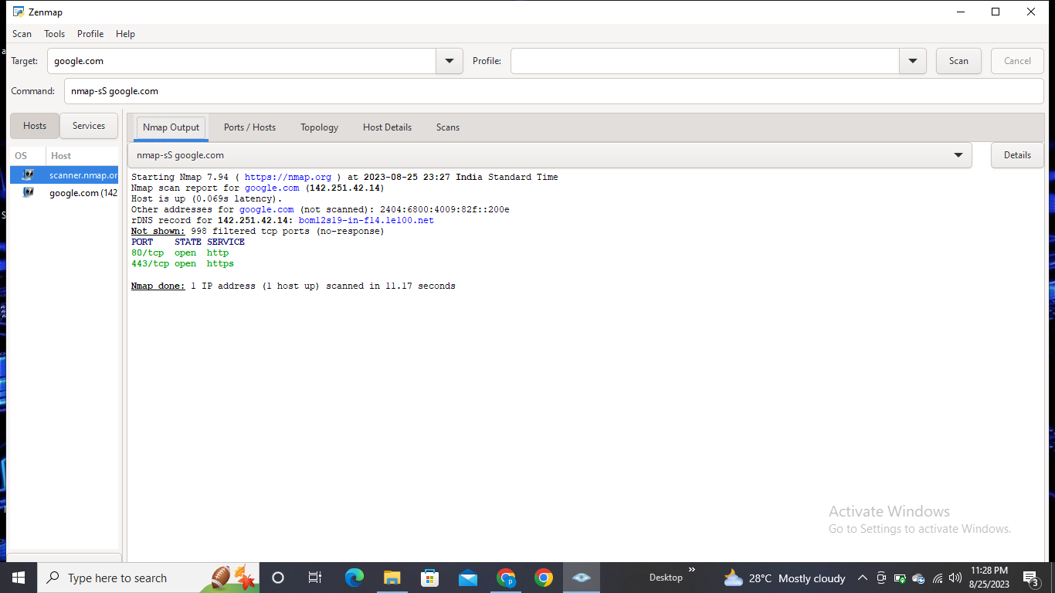

You can use the **‘-sS’** command to perform a stealth scan. Remember, stealth scanning is slower and not as aggressive as the other types of scanning, so you might have to wait a while to get a response.

* **Version scan:**

A version scan is a feature in Nmap that helps you identify the versions of services running on open ports of a target system. This information can be crucial forunderstanding potential vulnerabilities associated with specific software versions.

To perform a version scan in Nmap, use the following command:

nmap -sV targetIP

Replace targetIP with the IP address you want to scan. The -sV flag tells Nmap to conduct a version scan alongside the port scan. Nmap will attempt to gather information about the versions of services running on the open ports by analyzing responses received from the target system.Version scanning can provide insights into the software landscape of the target system, helping you make informed decisions about security measures and updates.

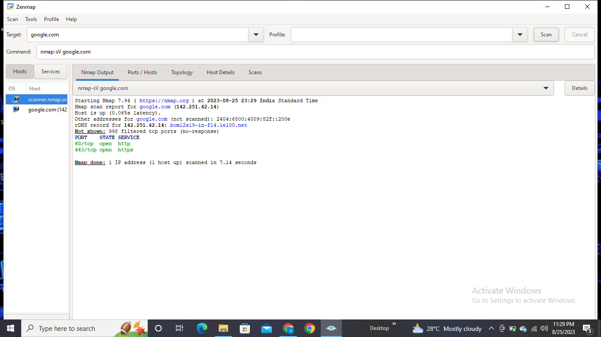

* **Aggressive scan:**

An "Aggressive Scan" in Nmap is a comprehensive scanning technique that combines various scan types and options to gather a wide range of information about the target system. It includes aspects like port scanning, version detection, operating system detection, script scanning, and traceroute. This type of scan is useful for getting an extensive view of the target's network environment, services, and potential vulnerabilities.

Here's the command for performing an aggressive scan using Nmap:

nmap -A targetIP

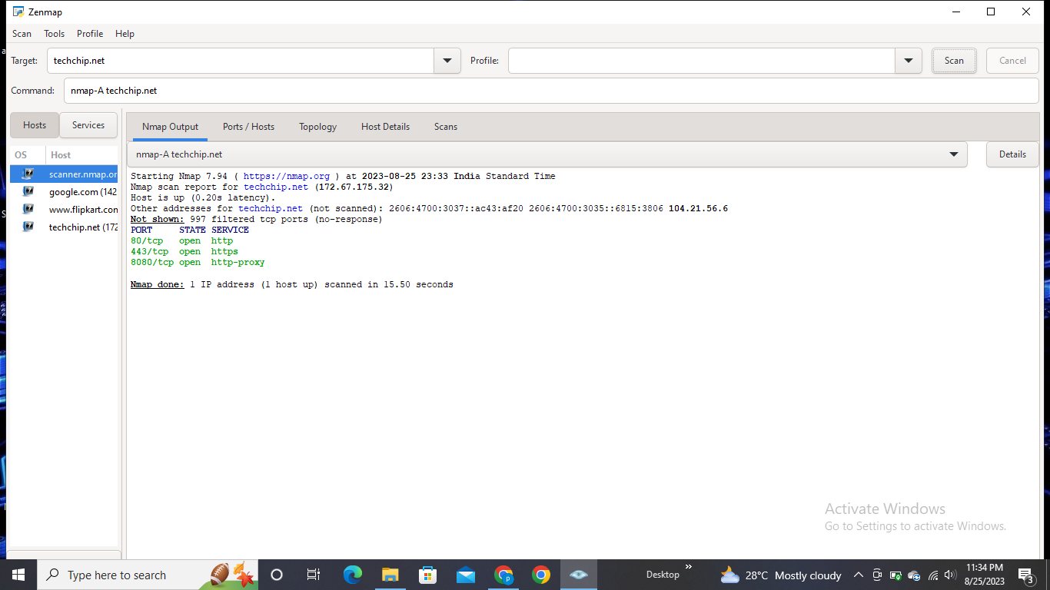

Replace targetIP with the IP address you want to scan. The -A flag instructs Nmap to enable aggressive scanning options, which include:

1)Port scanning: Determining open ports.

2)Version detection: Identifying service versions on open ports.

3)Operating system detection: Trying to identify the operating system.

4)Script scanning: Running NSE scripts to gather additional information.

5)Traceroute: Mapping the route to the target system.

* **Intense scan:**

An "Intense Scan" in Nmap is a scanning technique that aims to provide a balance between thoroughness and speed. It's designed to gather comprehensive information about the target system and its services while being faster than the most exhaustive scans like the "Aggressive Scan" or "Comprehensive Scan." The Intense Scan includes various scan types and options to achieve this balance.

Here's the command for performing an Intense Scan using Nmap:

nmap -T4 -A -v targetIP

Replace `targetIP` with the IP address you want to scan. The options used in this command include:

* + `-T4`: Sets the timing template to "Aggressive" (faster scanning speed).
  + `-A`: Enables aggressive scan options, including version detection, OS detection, script scanning, and traceroute.
  + `-v`: Increases the output verbosity for more detailed information.

The Intense Scan provides a good compromise between thoroughness and scan speed, making it a popular choice for security professionals looking to quickly assess a target's network environment. As always, ensure you have proper authorization before conducting any scanning activities on a network.

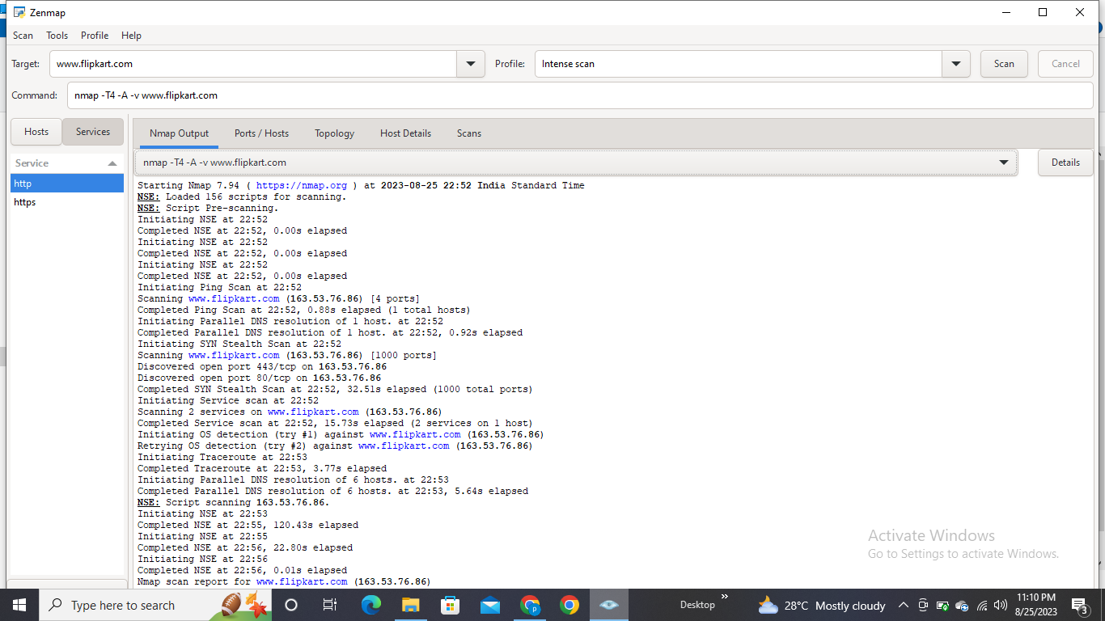

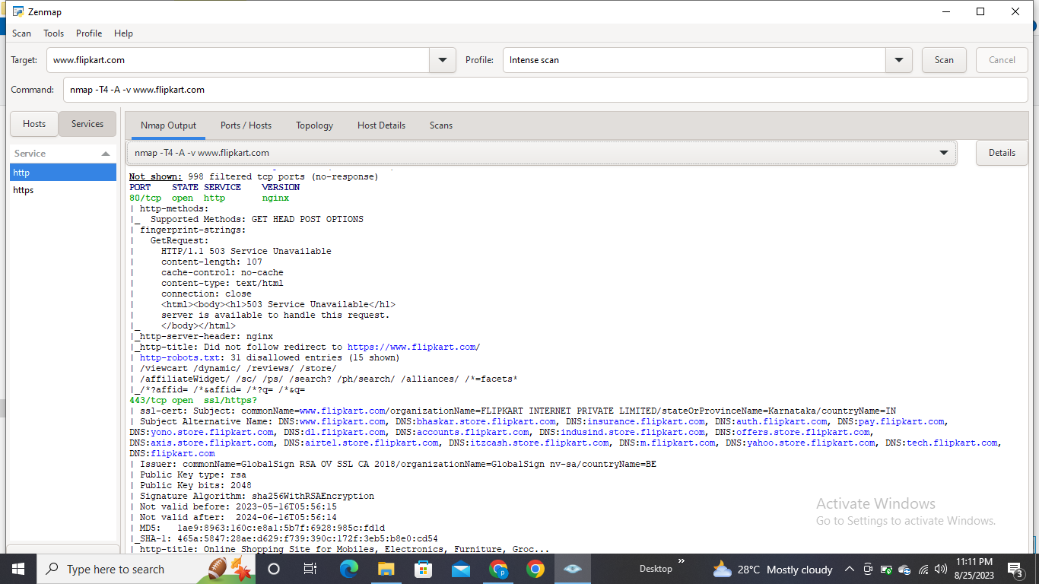

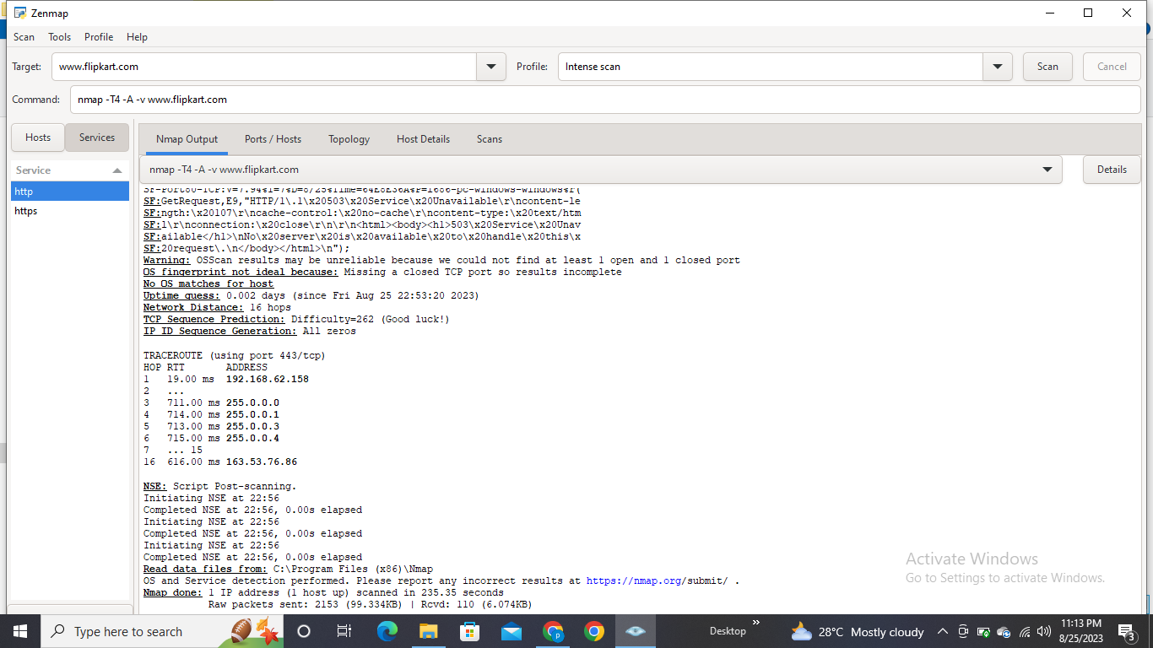Host details:

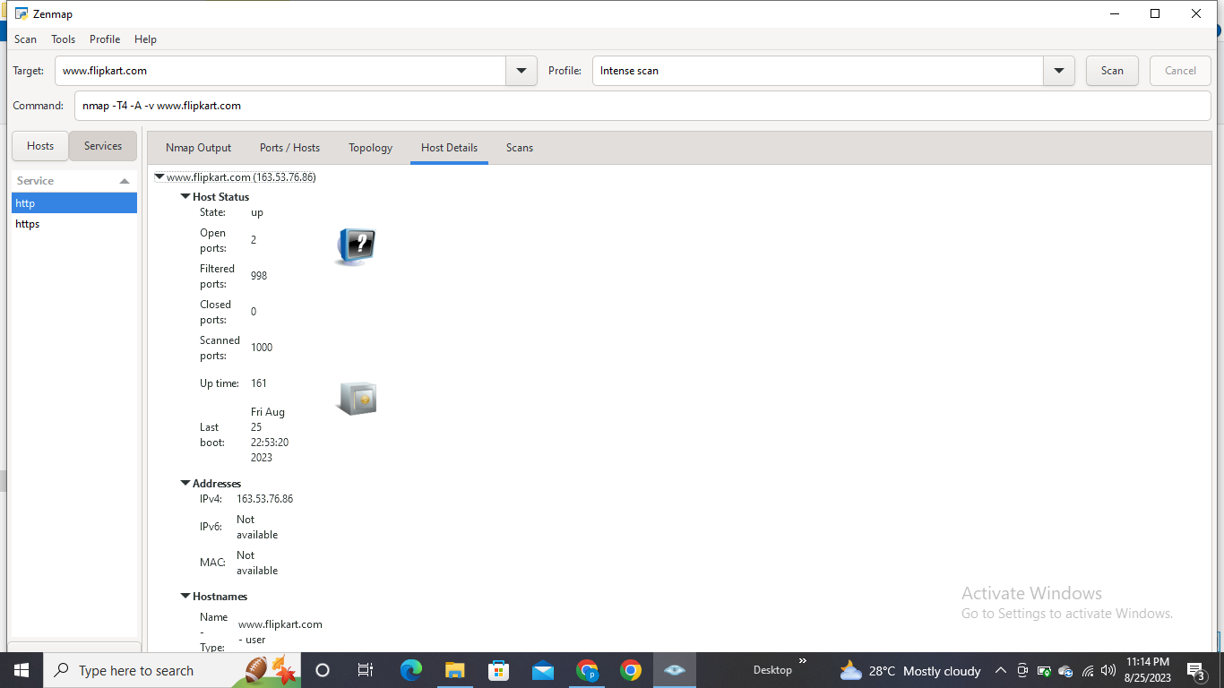

Topology:

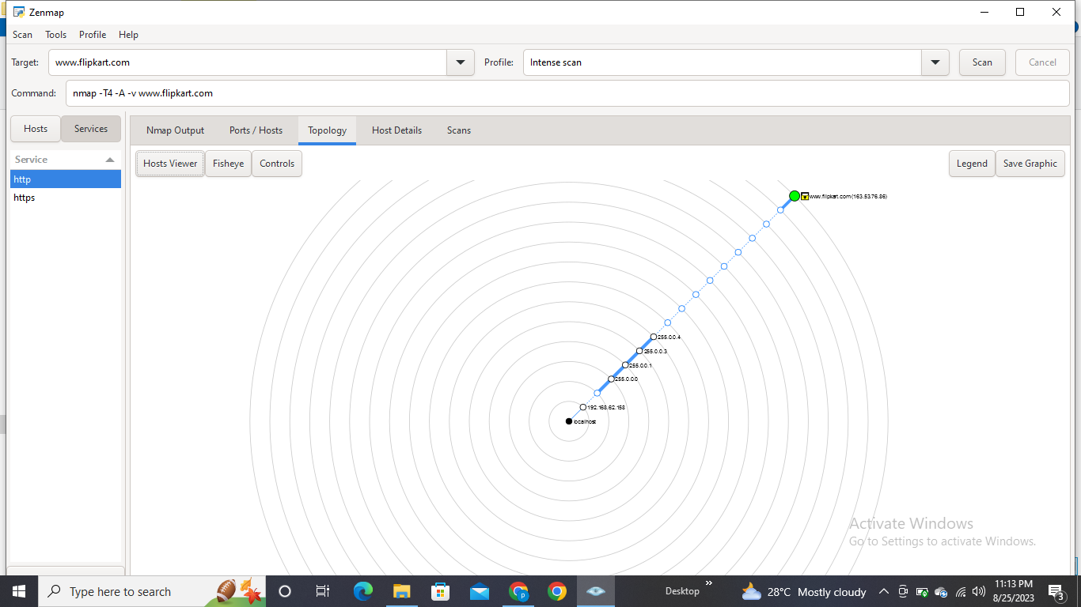

* **Scanning Multiple hosts:**

To scan multiple hosts using Nmap, you can simply list the IP addresses or hostnames of the targets you want to scan on the command line. Here's how you can do it:

nmap targetIP1 targetIP2 targetIP3 ...

Replace `targetIP1`, `targetIP2`, `targetIP3`, and so on with the actual IP addresses or hostnames of the targets you want to scan. You can list as many targets as needed, separated by spaces.

For example:

nmap 192.168.1.1 192.168.1.2 192.168.1.3

This command will perform a default scan on the three specified IP addresses.

Keep in mind that scanning multiple hosts might take more time and resources, so consider the impact on the network and systems you are scanning. Always ensure you have proper authorization before scanning any network.

* Use the asterisk (*) to scan all of the subnets at once.

> nmap 192.164.1.*

* Add commas to separate the addresses endings instead of typing the entire domains.

> nmap 192.164.0.1,2,3,4

* Use a hyphen to specify a range of IP addresses

> nmap 192.164.0.0–255

* **Port scanning**:Port scanning is a fundamental technique used to discover which network ports on a target system are open or closed. Nmap provides various options for performing different types of port scans. Here are a few examples:

1. TCP SYN Scan (Stealth Scan):

nmap -sS targetIP

This sends SYN packets and analyzes the responses to determine open ports.

2. TCP Connect Scan:

nmap -sT targetIP

This is a full connection scan, attempting to establish a full TCP connection to each port.

3. UDP Scan:

nmap -sU targetIP

This scans for open UDP ports. Note that UDP scans are less reliable due to the lack of response from closed ports.

4. Fast Scan (Scan common ports quickly):

nmap -F targetIP

5. Custom Port Range Scan:

nmap -p 80,443,8080 targetIP

This scans specific ports you specify.

**2] WRITE AND EXPLAIN COMMANDS IN WINDOWS COMMAND PROMPT FOR NETWORK /SERVER DETAILS.**

In the Windows Command Prompt, you can use various commands to gather network-related information. Here's how you can do it: Open the Command Prompt by searching for "cmd" in the Windows Start menu and selecting the Command Prompt application. Here are some useful commands:

1. **ipconfig:** This command displays the IP configuration for all network interfaces on your computer. It provides details such as IP address, subnet mask, default gateway, and more.

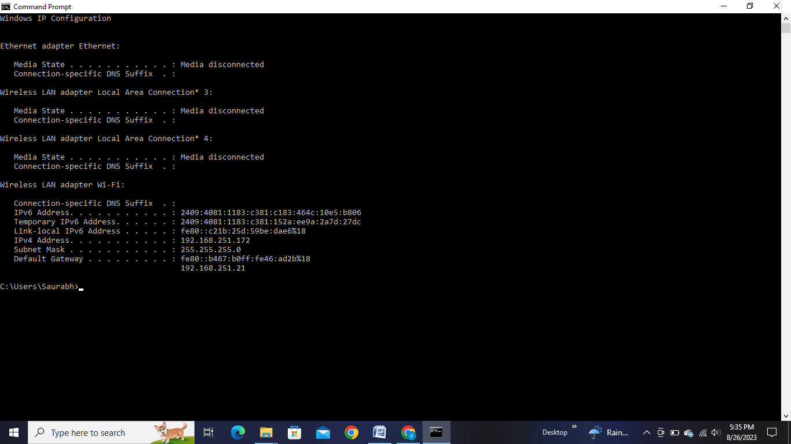

Look for the section labeled "Ethernet adapter" or "Wireless LAN adapter" depending on your connection type. Under this section, you will see your IP address listed as "IPv4 Address."The IP address displayed here is your local IP address on your current network.If you're looking for your public IP address (the one visible to the internet), you might need to use an online service or use a tool like curl to fetch it from a web service. Keep in mind that your public IP address might change periodically if you have a dynamic IP from your ISP.

2. **Ping:** The ping command is used to test the connectivity between your computer and another device or server on the network. It also shows the round-trip time for data packets.

Example: `ping WWW.google.com`

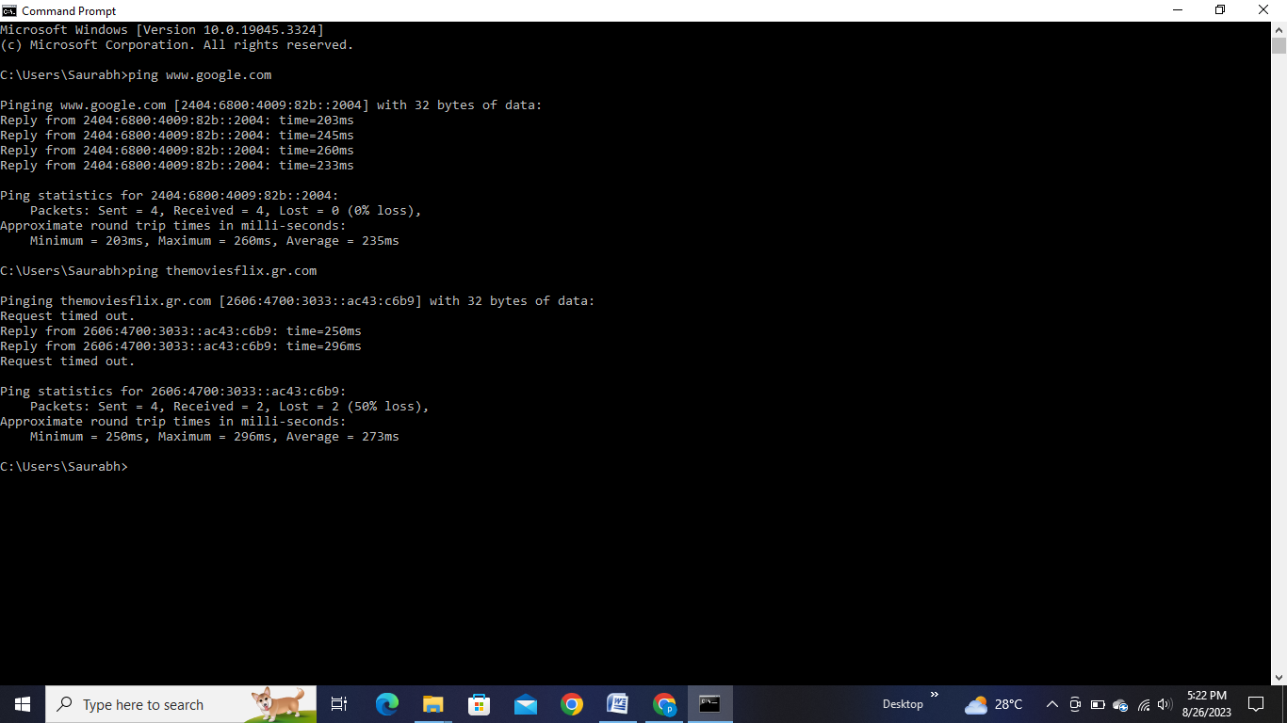

3. **tracert (or traceroute on other systems**): This command traces the route that packets take from your computer to a destination server, showing the IP addresses of each hop along the way.

In the Command Prompt window, type the following command and press Enter : tracert <destination_address> Replace <destination_address> with the domain name or IP address of the server you want to trace the route to.

Example: `tracert google.com`

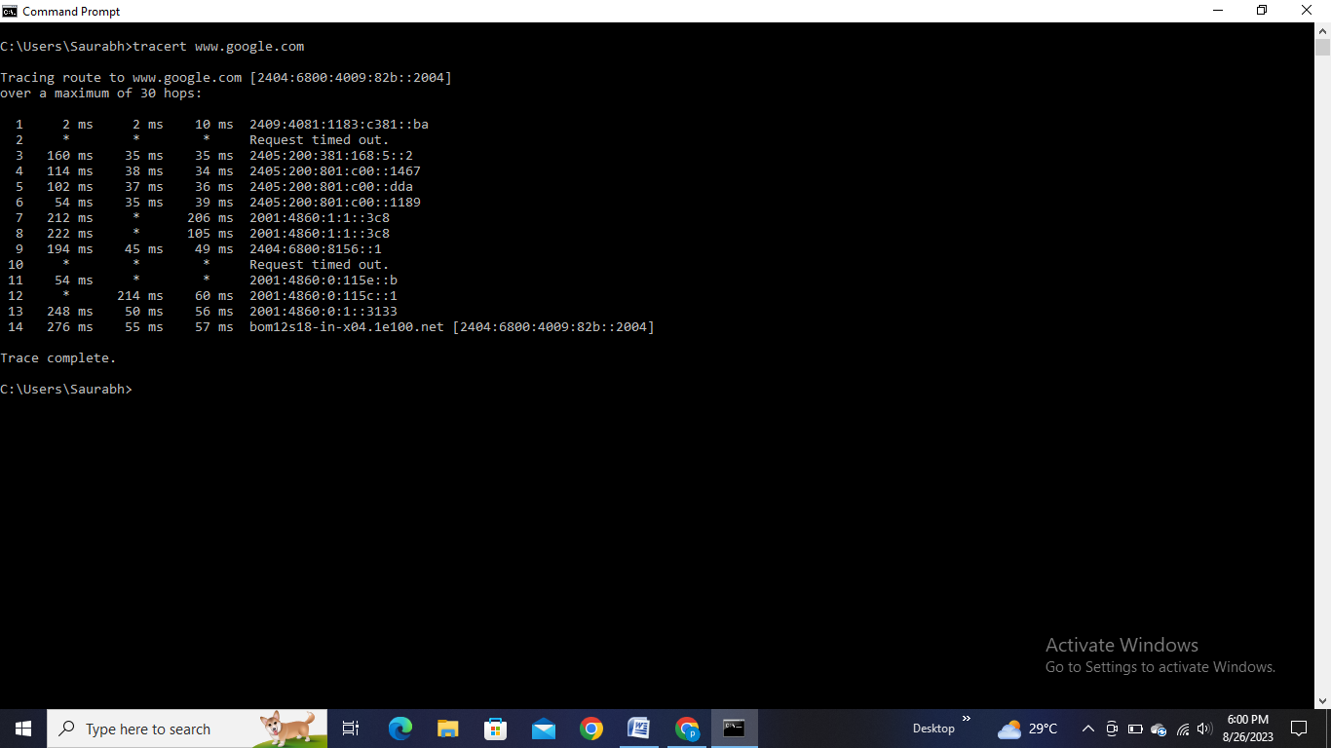

4. **nslookup**: The nslookup command is used to perform DNS queries to retrieve information about domain names, including their corresponding IP addresses.

In the Command Prompt window, type the following command and press Enter : nslookup <domain_name> Replace <domain_name> with the domain name for which you want to perform a DNS lookup.

Example: nslookup google.com

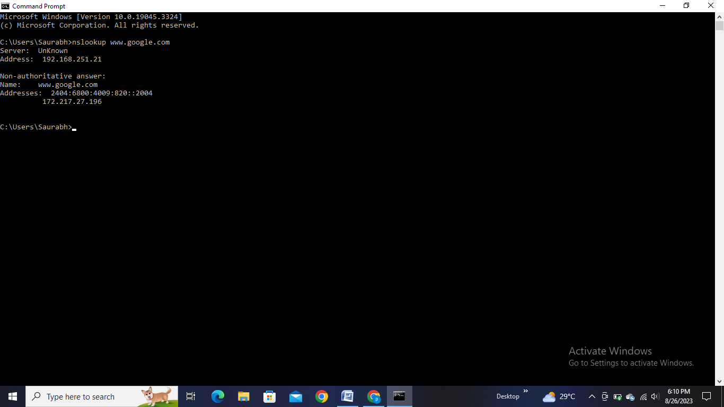

The command will provide information about the domain name and its associated IP addresses. It will display the authoritative DNS server that provided the information as well.If you want to retrieve information about a specific type of DNS record (such as MX records for email servers), you can specify the record type after the domain name.

For example: nslookup google.com MX

The output will include the IP addresses corresponding to the domain name, the name and IP address of the authoritative DNS server, and other DNS-related information.nslookup is a valuable tool for troubleshooting DNS-related issues, verifying DNS configurations, and understanding how domain names are resolved to IP addresses on the internet.

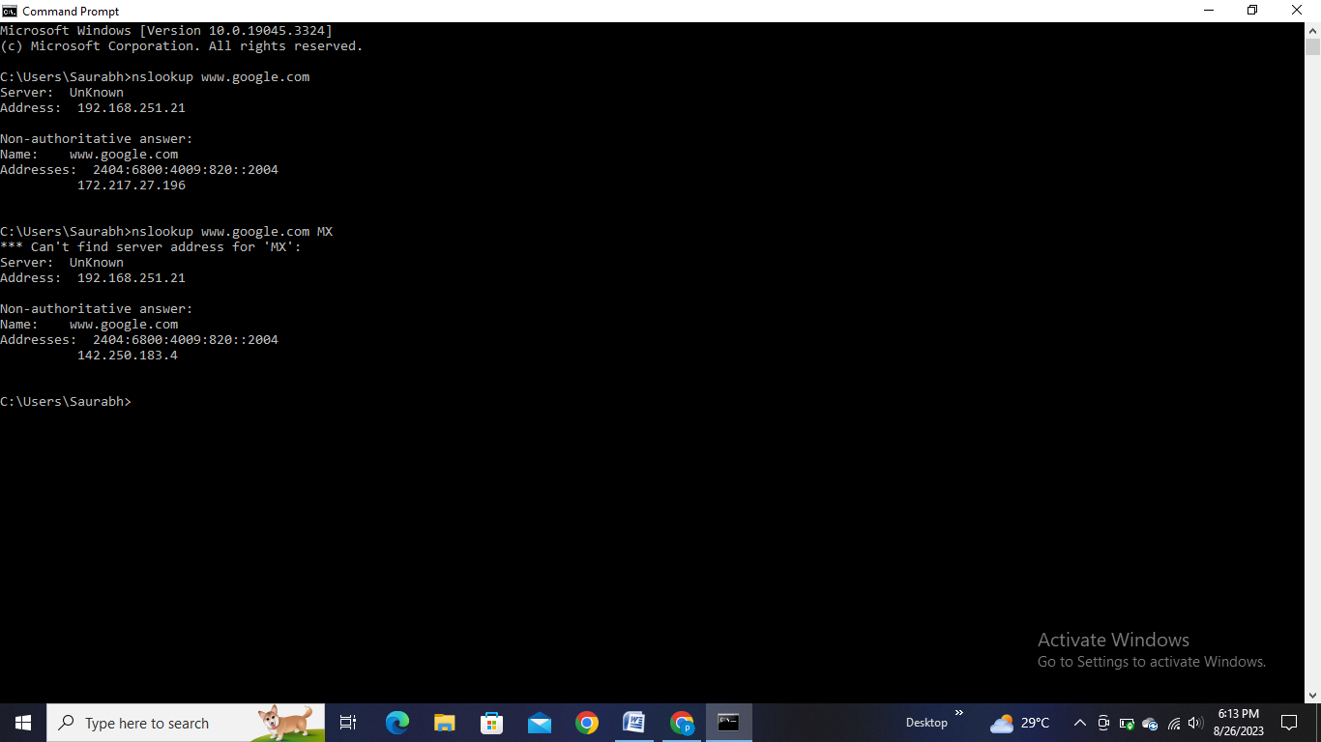

5. **netstat**: This command displays various network-related information, such as active network connections, listening ports, and statistics.

Example: `netstat -a`

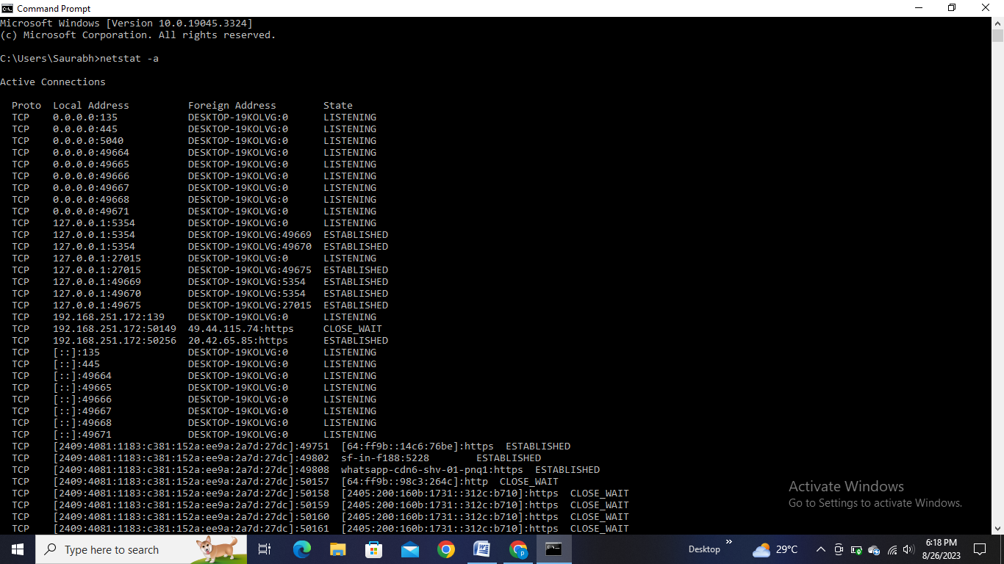

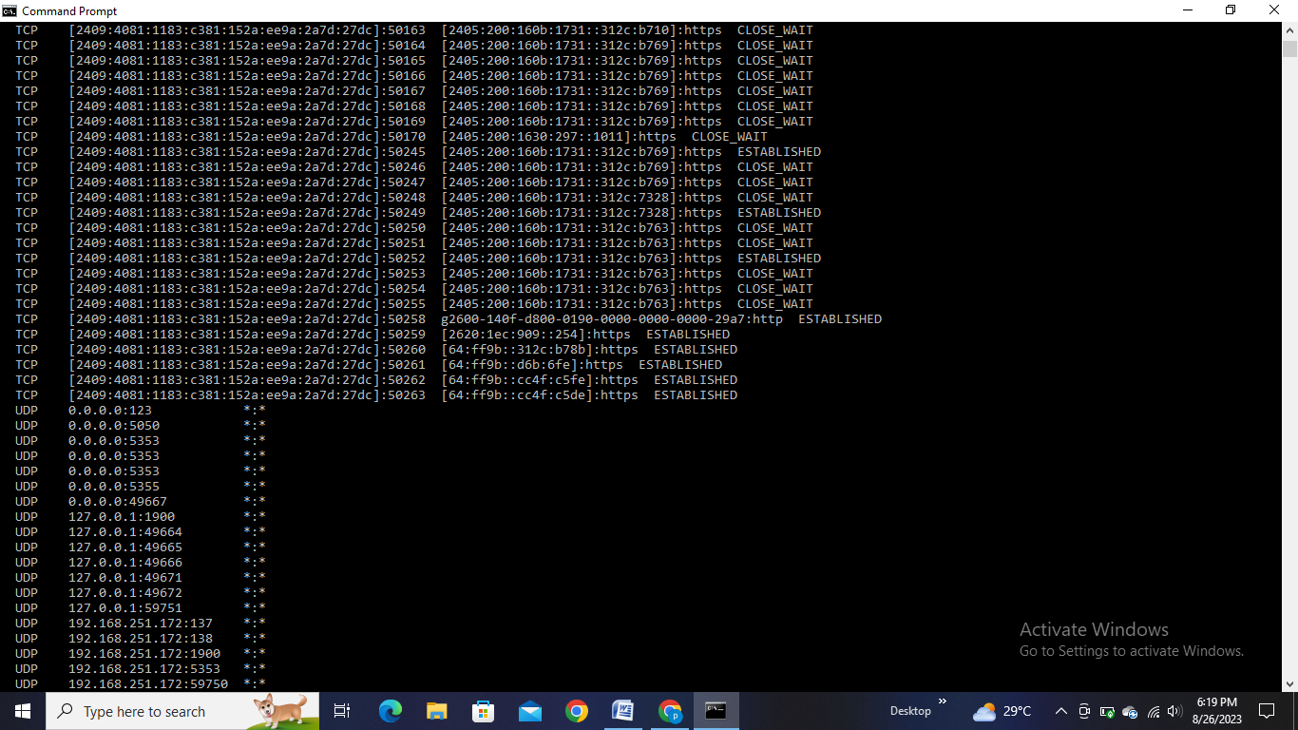

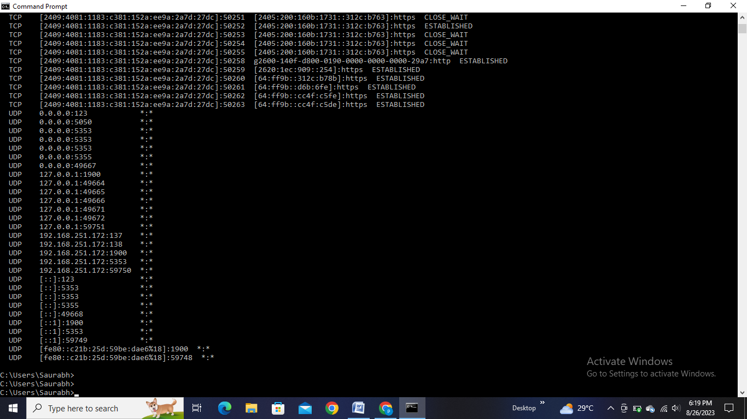

6. **arp :** The arp command shows and modifies the Address Resolution Protocol (ARP) cache, which maps IP addresses to MAC addresses.

Example: `arp -a`

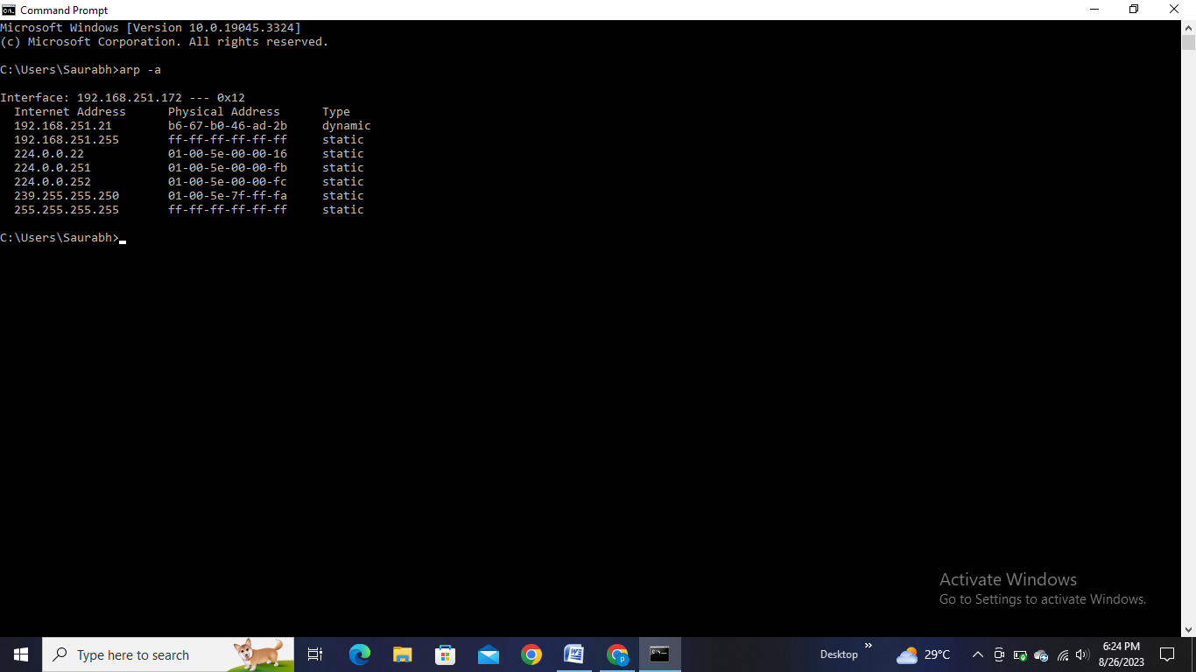

7. **route**: This command displays and modifies the local IP routing table, showing how your computer routes network traffic. Example: `route print`

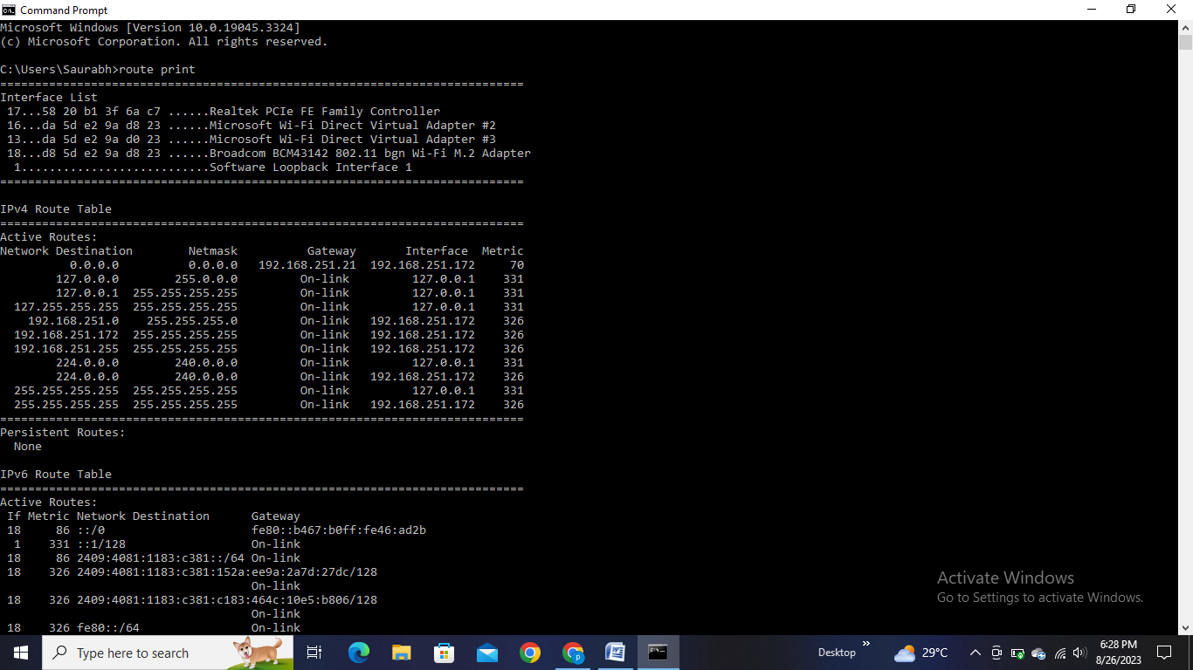

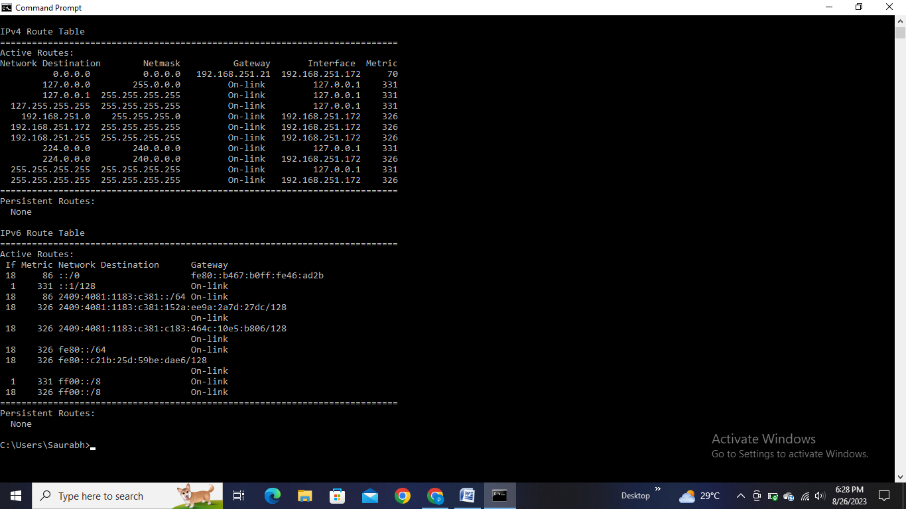

These commands should help you gather different types of network-related information using the Windows Command Prompt. Just type the command followed by the appropriate options and parameters to get the details you need.

**3] USE WEBSITE COPYING TOOL FOR WEBSITE COPY(HT-TRACK).**

HTTrack is a popular open-source website copying utility that allows you to download a website's content, including HTML, images, and other media, for offline browsing. It essentially creates a local mirror of a website on your computer. It can be useful for creating backups of websites, offline browsing, or archiving purposes. Just remember to use it responsibly and respect the website's terms of use and copyright restrictions.

Using HTTrack is relatively straightforward. Here's a basic guide to get you started:

**1. Download and Install HTTrack:** Visit the official HTTrack website (https://www.httrack.com/) and download the version of HTTrack that corresponds to your operating system (Windows, Linux, macOS, etc.). Install the software like you would with any other program.

**2. Launch HTTrack:** Once installed, open HTTrack.

**3. Create a New Project:**

- Click on "Next" on the first screen.

- Enter a name for your project in the "Project name" field.

- Choose the location on your computer where you want to save the downloaded website files. Click "Next."

**4. Set Your Base Path:**

- Enter the starting URL of the website you want to copy in the "Web Addresses (URL)" field. This is the main page of the website.

- Click "Add URL" and then "Next."

**5. Configure Options:**

- You can choose various options on this page, such as setting the maximum mirroring depth, setting filters to exclude certain files or URLs, and more. The default settings are usually fine for most purposes.

**6. Start Downloading:**

- Click "Finish" to start the downloading process. HTTrack will begin fetching the website's content and storing it on your computer.

**7. Monitor Progress:**

- You'll see a progress bar indicating the status of the download. You can pause, resume, or stop the download at any time.

**8. Browsing the Downloaded Website:**

- Once the download is complete, navigate to the folder where you specified the project to be saved. Inside, you'll find a folder named after your project. Open this folder to access the downloaded website's files.

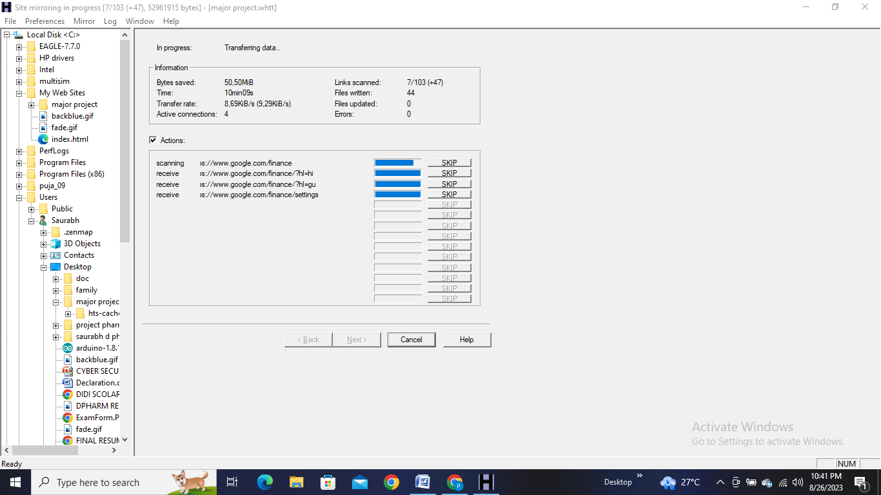

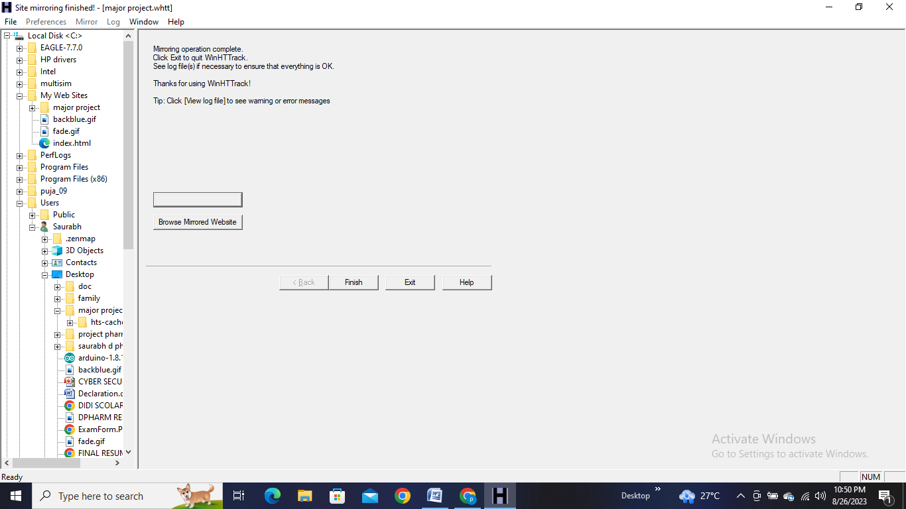

Please note that larger websites with complex structures and many files may take a while to download. Additionally, be considerate of the website's terms of use and respect copyright restrictions when using HTTrack.

There are more advanced settings and options available in HTTrack for specific use cases. Always consult HTTrack's documentation or help resources.

**4] USE WIRESHARK TOOL FOR PACKET CAPTURING:**

Wireshark is a popular open-source network protocol analyzer. It allows you to capture and analyze the traffic on a network in real-time. You can use it to troubleshoot network issues, inspect packets, and understand the communication between devices. Wireshark supports a wide range of protocols and provides detailed information about each packet, making it a valuable tool for network administrators, security professionals, and developers.

Wireshark is a powerful network protocol analyzer that offers various features, including:

**1. Packet Capture:** Wireshark captures and displays network packets, allowing you to analyze network traffic in real-time or from saved capture files.

**2. Packet Filtering:** You can apply filters to capture specific types of traffic, such as those originating from or destined to specific IP addresses or protocols.

**3. Protocol Decoding:** Wireshark can dissect and decode a wide range of network protocols, making it useful for troubleshooting and understanding network communication.

**4. Coloring Rule:** It uses customizable coloring rules to highlight specific packets or fields, making it easier to identify important information.

**5. Statistics:** Wireshark provides statistics on network traffic, including conversations, packet rates, and network endpoints.

**6. Display Options:** Users can customize the way packets are displayed, adjusting columns, fonts, and colors to suit their preferences.

**7. Follow Streams**: You can follow a network stream to see the entire conversation between two endpoints, helping to understand the sequence of packets exchanged.

**8. VoIP Analysis:** Wireshark supports the analysis of Voice over IP (VoIP) protocols, helping diagnose call quality issues.

**9. Exporting Data:** Captured packets can be exported to various formats for further analysis or reporting.

**10. Lua Scripting:** It supports Lua scripting, allowing users to create custom dissectors and add functionality to Wireshark.

**11. Search and Filtering**: Wireshark provides search and filtering capabilities to locate specific packets or data within captured traffic.

**12. Packet Reassembly:** The tool can reassemble fragmented packets, such as those used in IP fragmentation, to display the complete payload.

**13. Graphing:** Users can create graphs to visualize packet-related statistics, making it easier to understand trends and patterns.

**14. Colorization Rules**: You can define custom color rules to highlight packets based on specific conditions, aiding in quick identification of issues.

**15. Remote Capture:** Wireshark can capture packets from remote machines using protocols like SSH, making it possible to analyze network traffic on distant servers.

**16. Expert Info:** The tool provides information about potential problems in the captured traffic, helping in troubleshooting issues.

This is not an exhaustive list, but it covers some of the **notable features** that **Wireshark** offers for network analysis and troubleshooting.

* Using Wireshark involves a few basic steps:

1. **Install Wireshark:** You can download and install Wireshark from their official website. Make sure to choose the version compatible with your operating system.

2. **Launch Wireshark:** Once installed, open the Wireshark application.

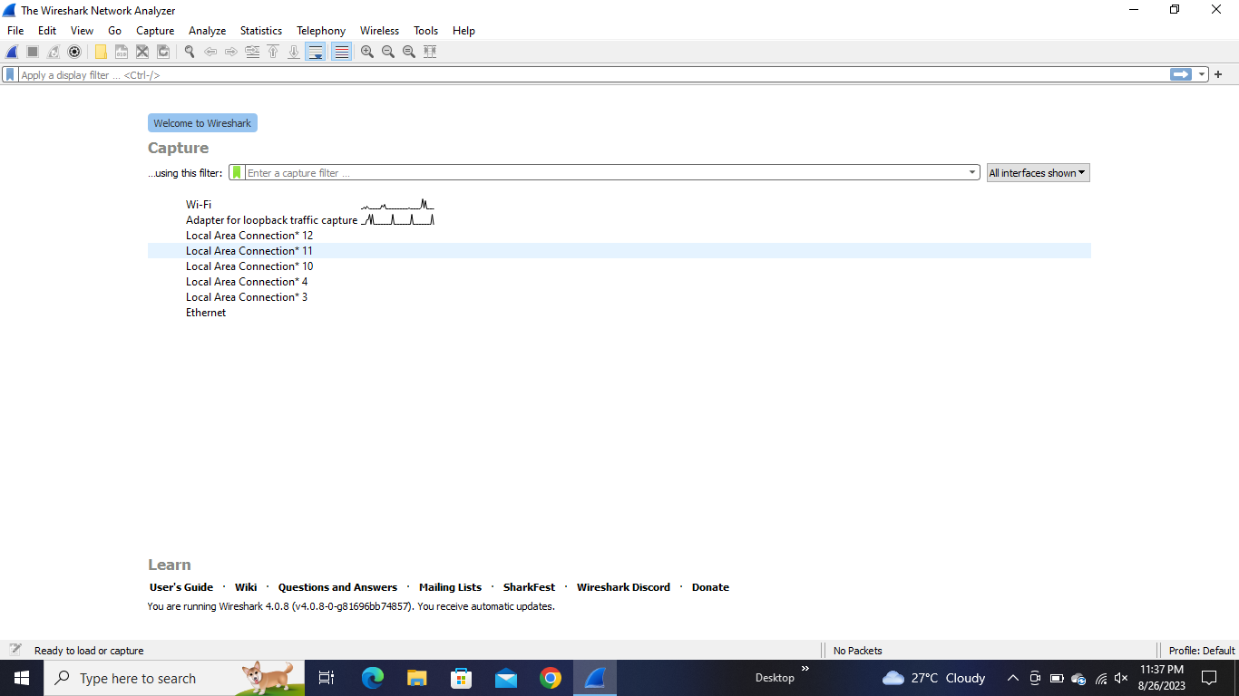

3. **Select Network Interface:** Choose the network interface you want to capture traffic from. This could be your Wi-Fi or Ethernet connection. Click on the interface to start capturing packets.

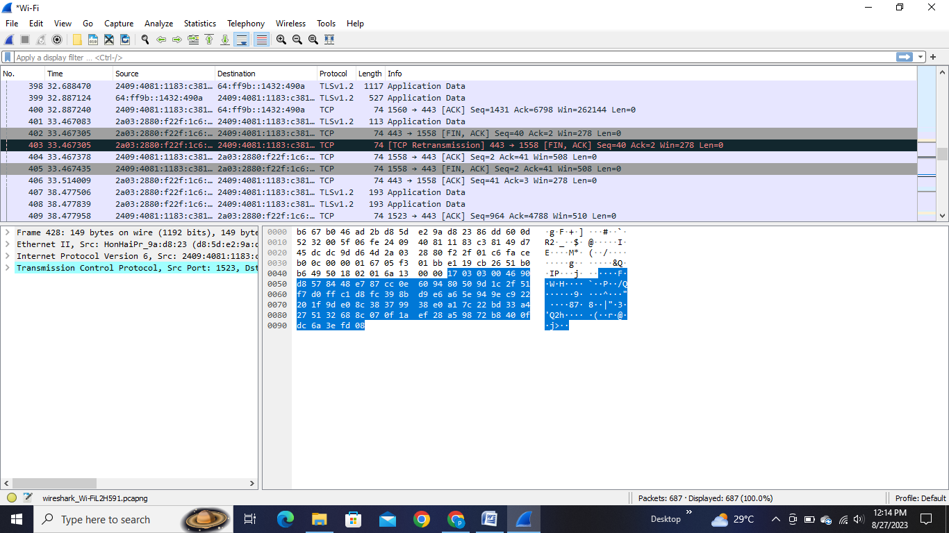

4. **Capture Packets:** Wireshark will start capturing packets on the selected interface. You'll see a live feed of captured packets in the main window.



5. **Filter Packets (Optional):** You can apply filters to focus on specific types of traffic, protocols, or devices. This helps narrow down the captured data for analysis.

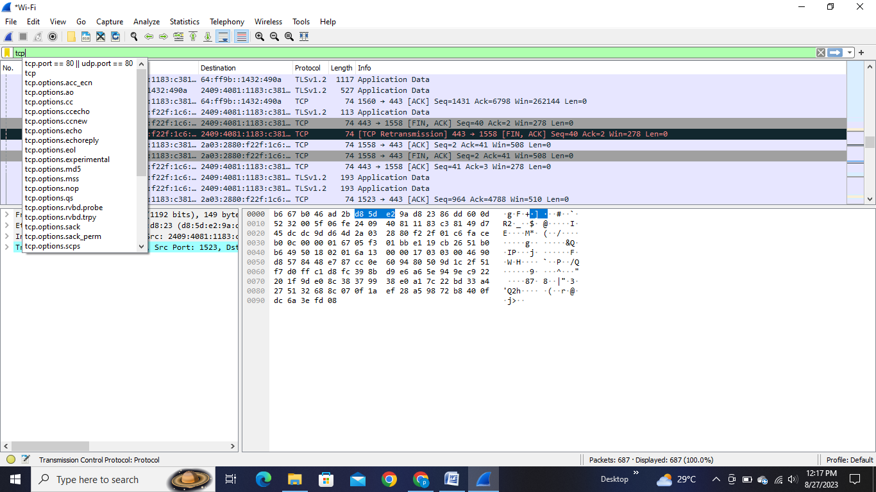

6. **Analyze Packets:** Click on individual packets to see detailed information. Wireshark provides various views and dissectors to help you interpret packet data, such as the raw packet bytes, protocol hierarchy, and more.

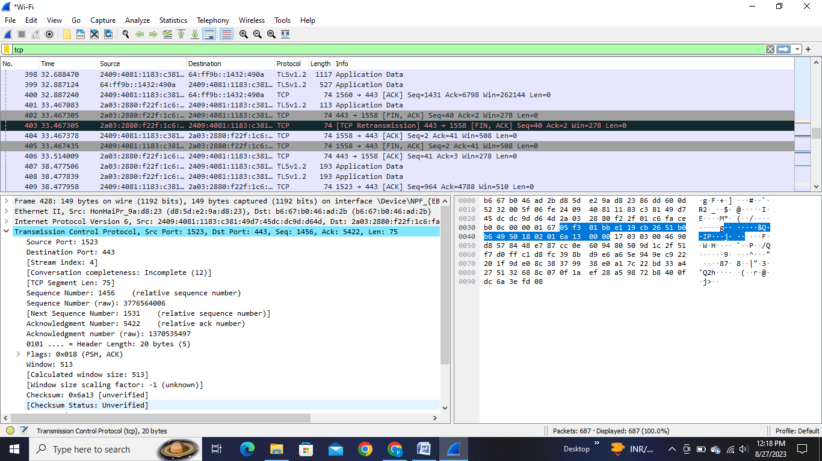

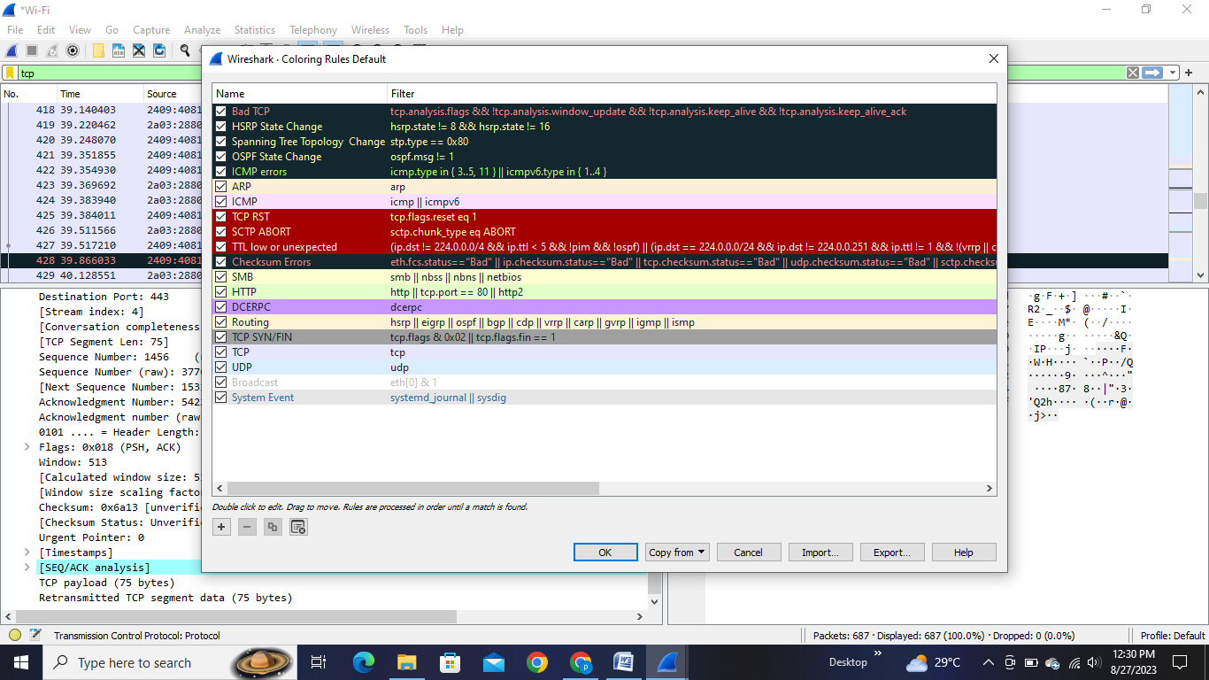

7. **Follow Streams:** Wireshark can reconstruct and display conversations between devices as streams. This is useful to see the flow of data between endpoints.

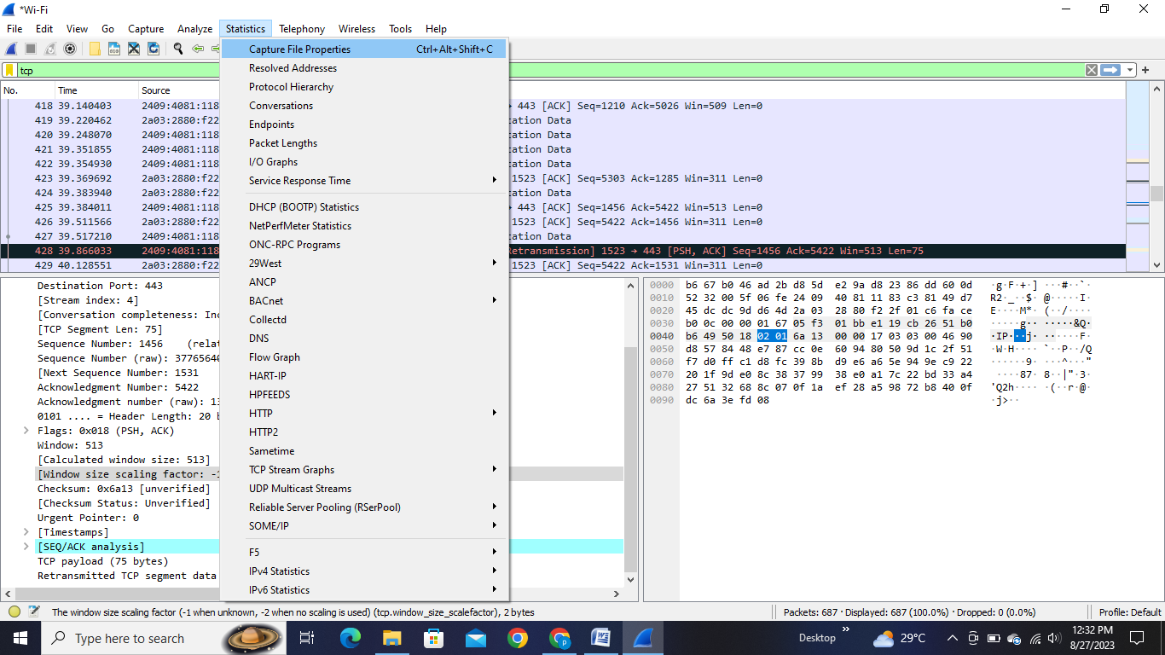

8. **Save and Export:** You can save captured packets for later analysis or export them in various formats. This is helpful if you need to share the data with others or analyze it offline.

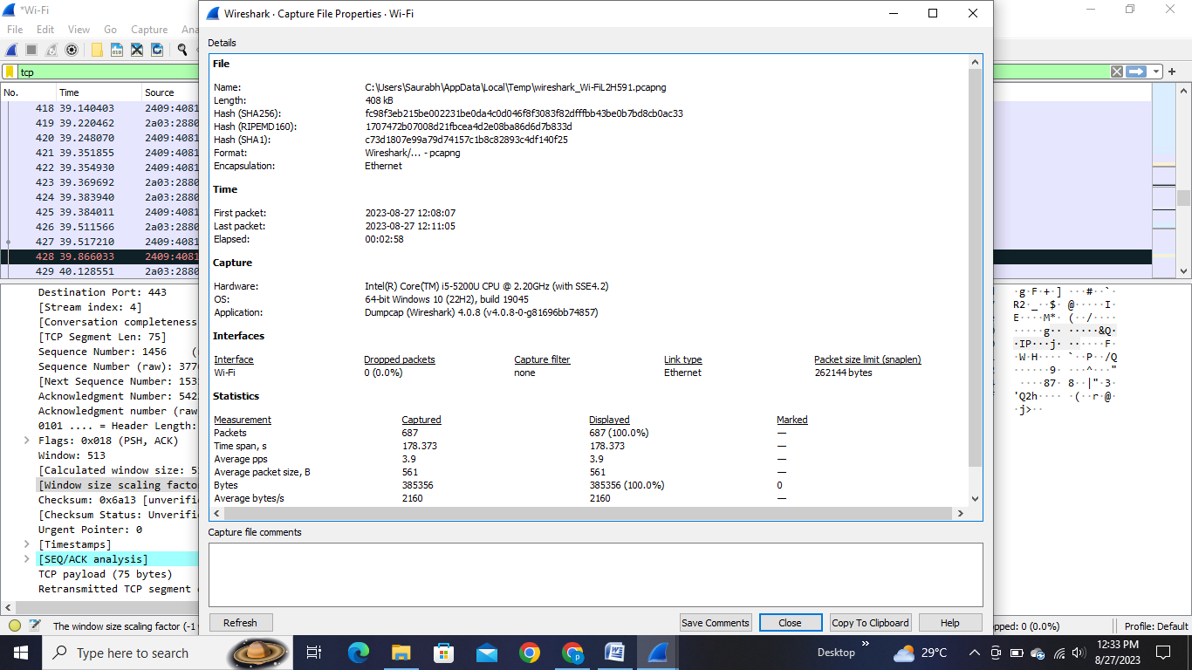

9. **Stop Capture:** Once you've captured the required data, stop the capture process.

10. **Analysis:** Analyze the captured packets to troubleshoot network issues, understand communication patterns, or identify anomalies.

Wireshark can capture a lot of data quickly, so it's important to filter and focus on what you're interested in. Additionally, Wireshark has a learning curve, so consider referring to tutorials or guides for more advanced features and techniques. Also, be mindful of privacy and legal considerations when capturing network traffic.

**5] TOOLS FOR FINDING DETAILS OF ANY NETWORK OR SERVER/WEBSITE (IP LOOKUP WEBSITE).**

An IP address lookup website, such as "iplocation.io," allows you to input an IP address and receive information about its geographical location, including details like the country, region, city, latitude, and longitude. This can be useful for various purposes, such as understanding the origin of internet traffic or troubleshooting network issues. Just enter the IP address you're interested in on the website, and it will provide you with the relevant location details associated with that IP address.

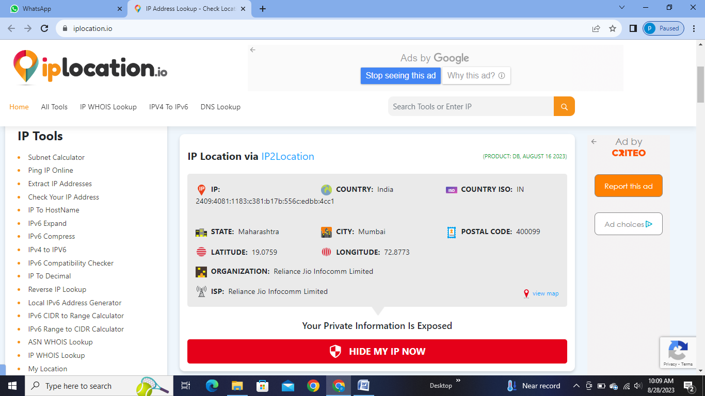

IP Location Lookup tool provides you free location tracking of an entered IP Address. It tracks the IP's city, country, latitude, and longitude data instantly through various Geo IP Databases available in the market.

If you are concerned about the GeoLocation data accuracy for the data listed below, please review the GeoLocation accuracy information for clarification.

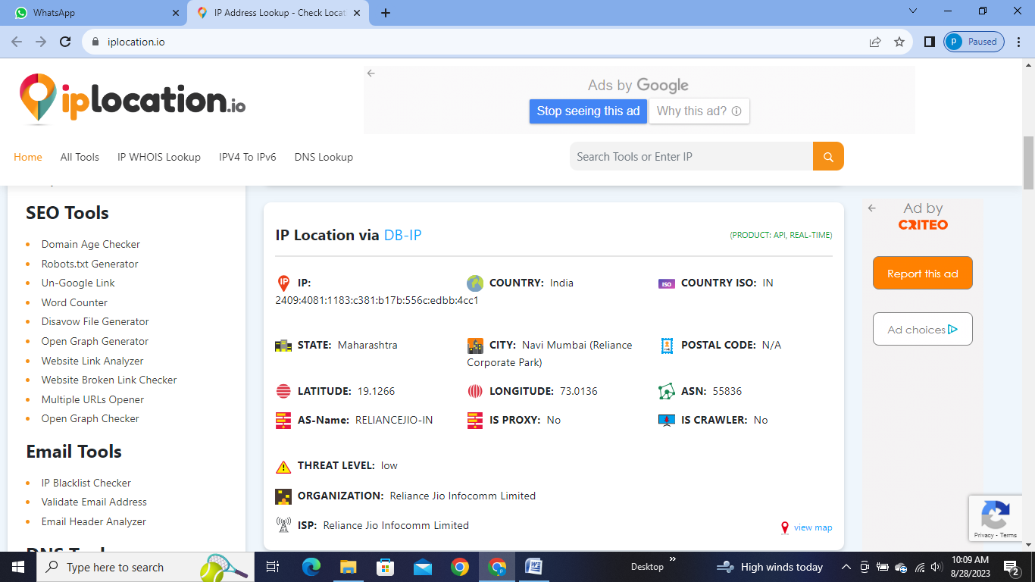

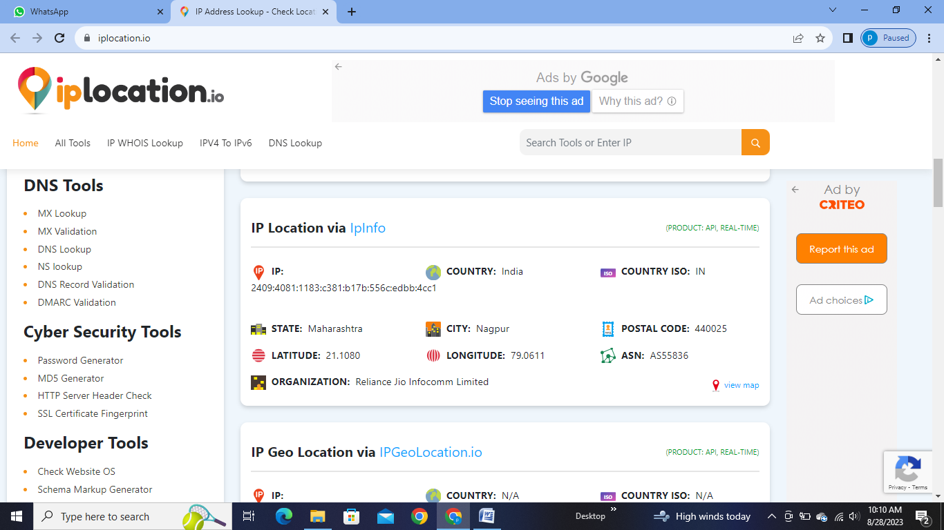

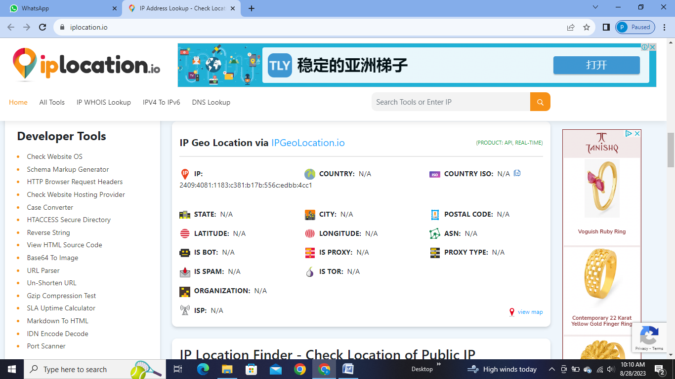

There are several tools you can use to find details about a network or server:

**1. Ping:** This basic command-line tool helps you determine if a specific IP address or domain is reachable and responsive.

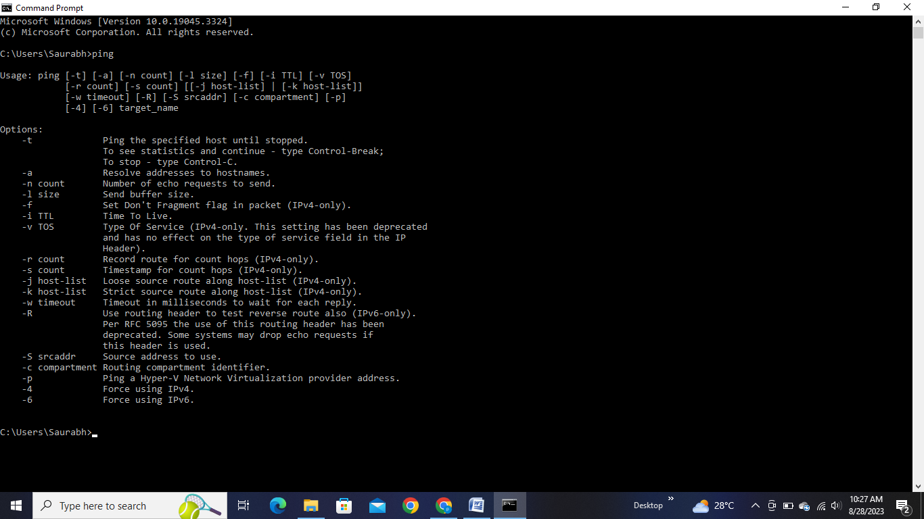

It also provides information about the time it takes for data packets to travel back and forth. Here is used random ip address using ping command to display:

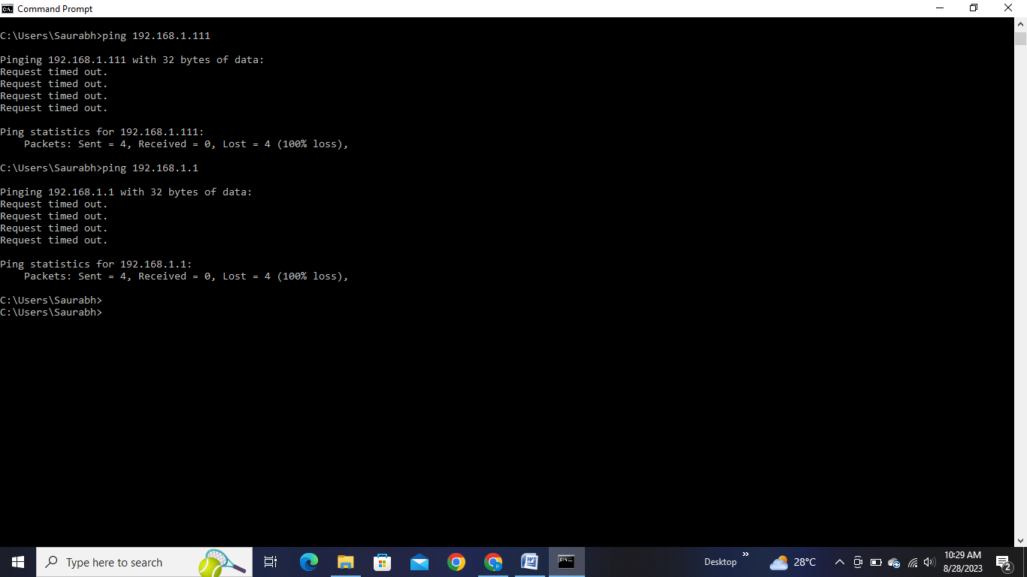

**2. Traceroute/Tracert:** These tools show you the route that data packets take from your computer to a destination server. They display each "hop" along the way and the time it takes to reach each hop.

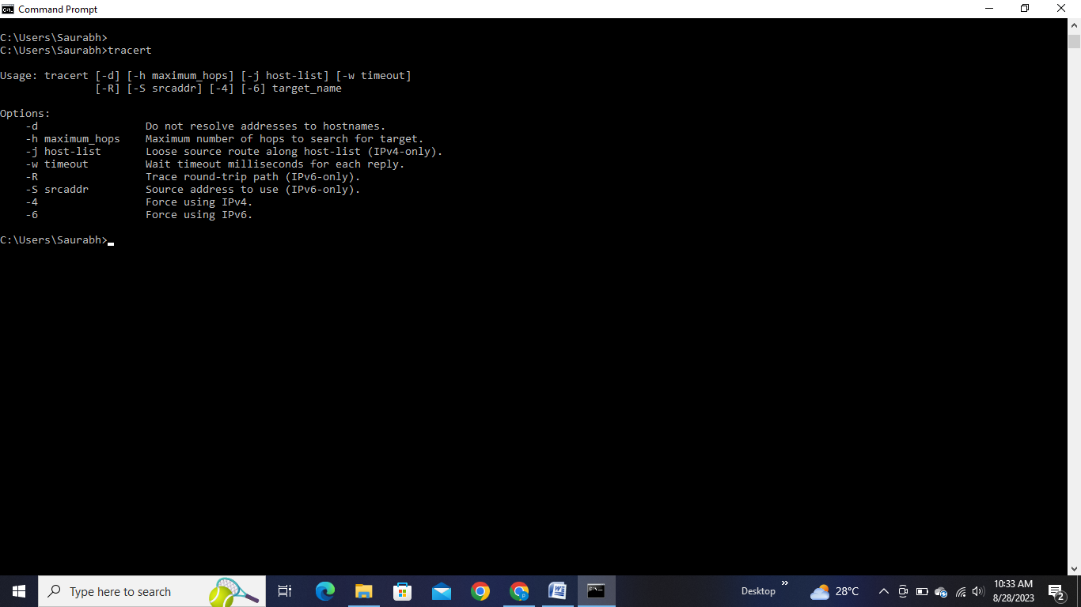

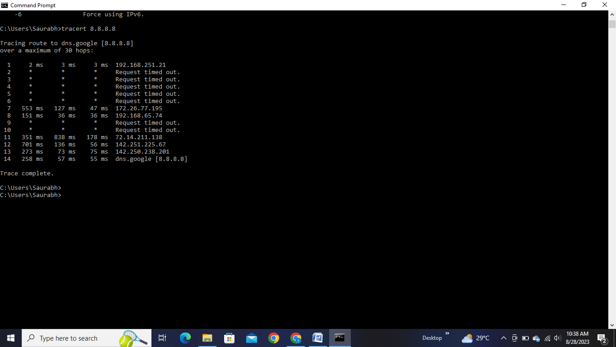

**3. Nslookup/Dig:** These tools allow you to query DNS (Domain Name System) information for a specific domain or IP address. They provide details about the domain's associated IP addresses and vice versa.

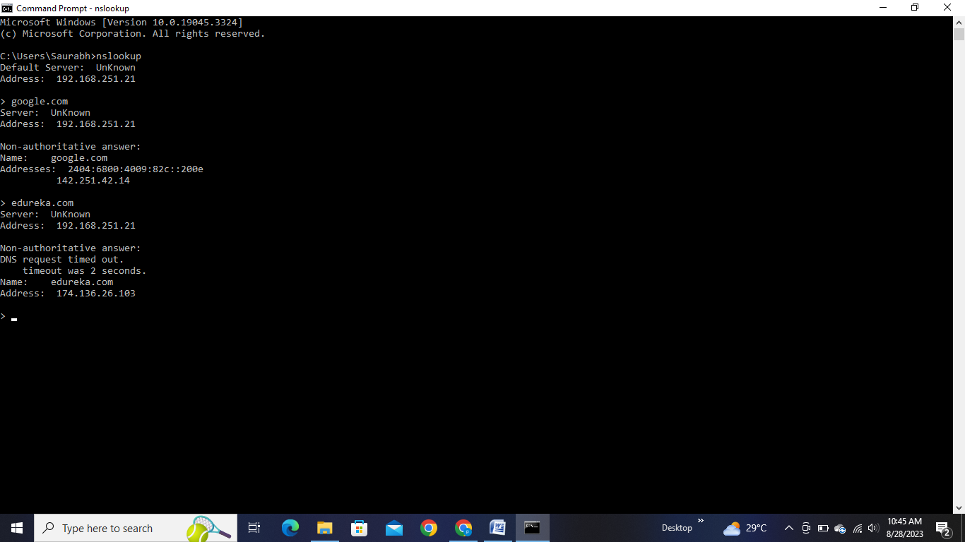

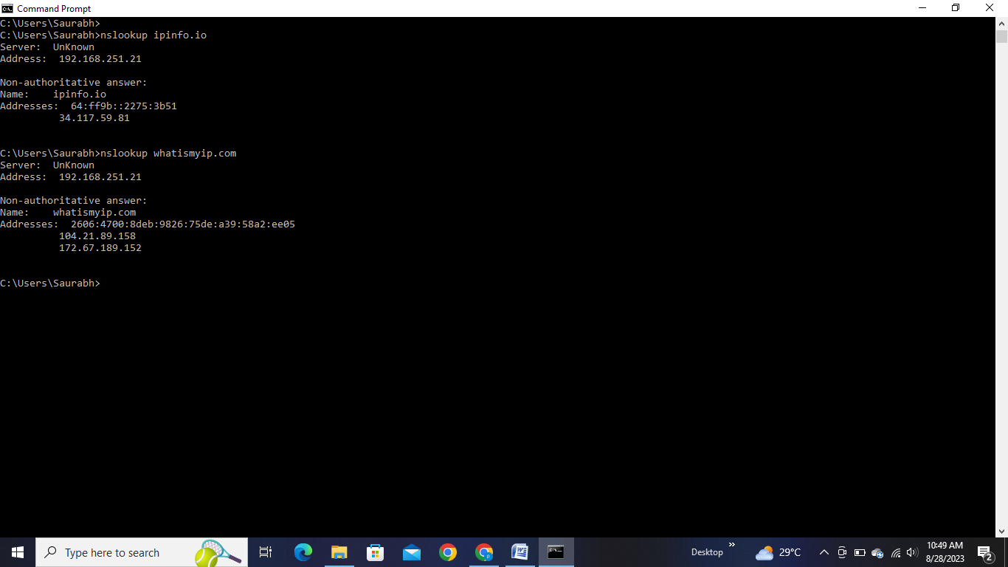

**4. Whois:** The "whois" command or website can be used to find registration and ownership details of a domain name, including the organization, contact information, and more.

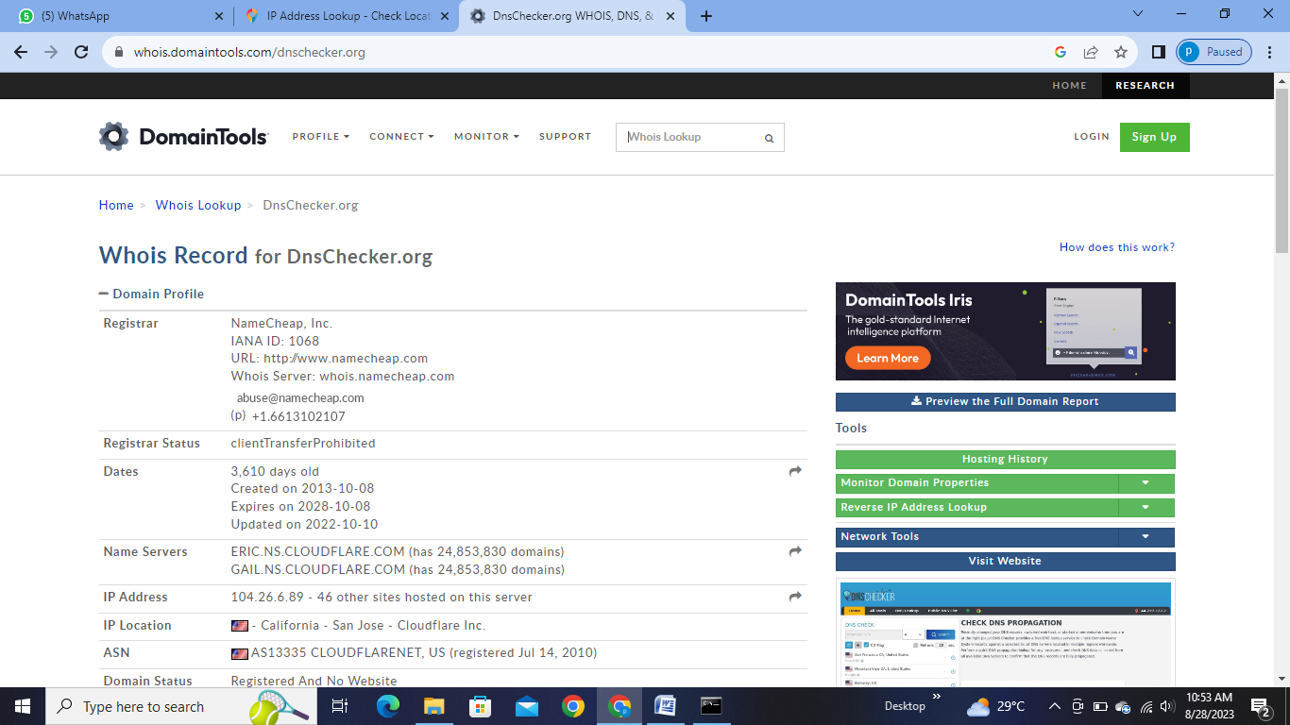

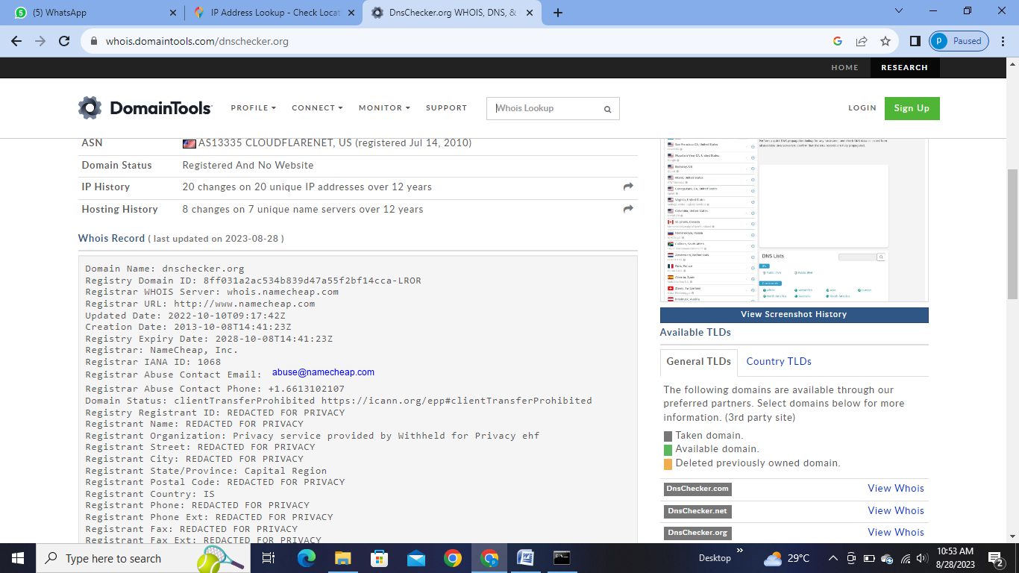

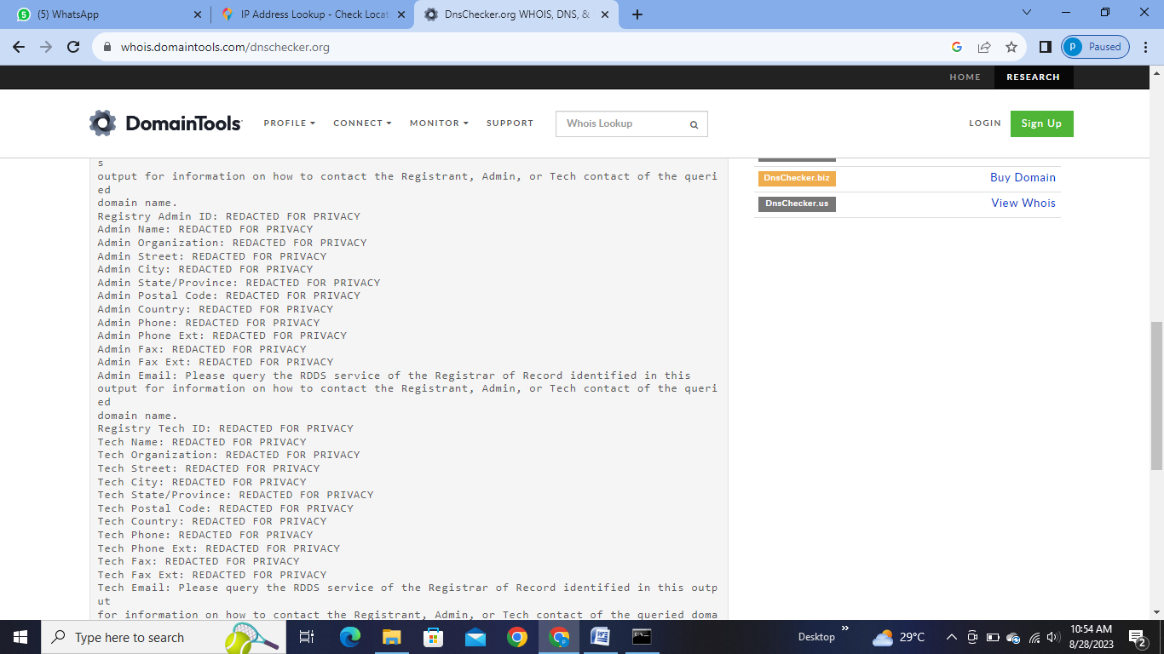

**5. Nmap:** Nmap is a powerful tool for network discovery and security auditing. It can scan hosts and services on a network, revealing details about open ports, running services, and more.







**6. Wireshark:** Wireshark is a network protocol analyzer that captures and displays the data traveling back and forth on a network. It's useful for diagnosing network issues and analyzing network traffic.

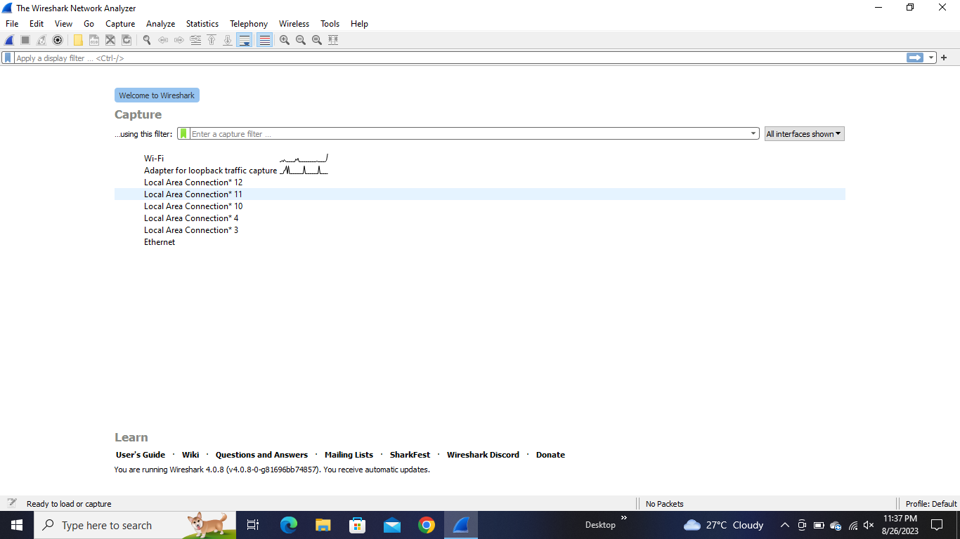



**7. Netstat:** This command-line tool provides information about network connections, routing tables, interface statistics, masquerade connections, and more.

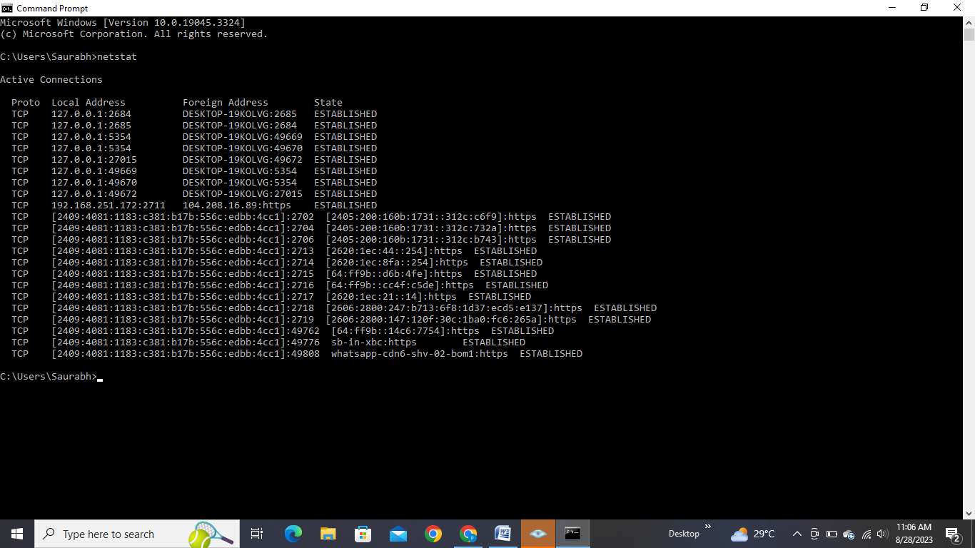

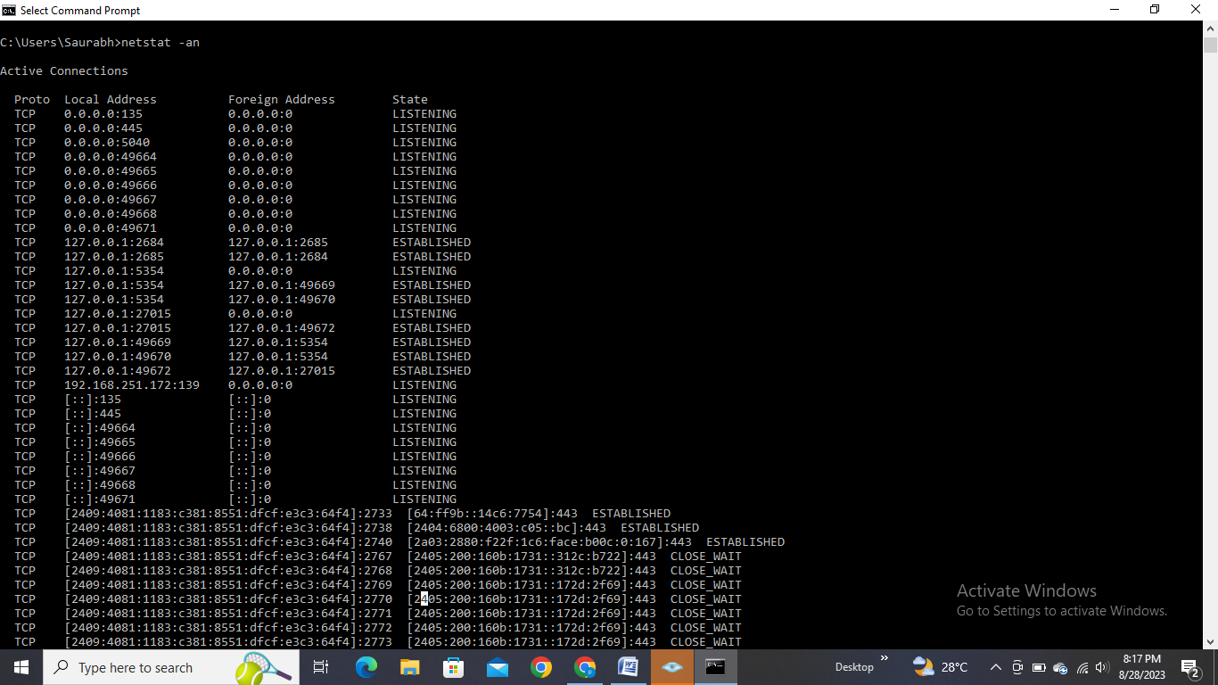

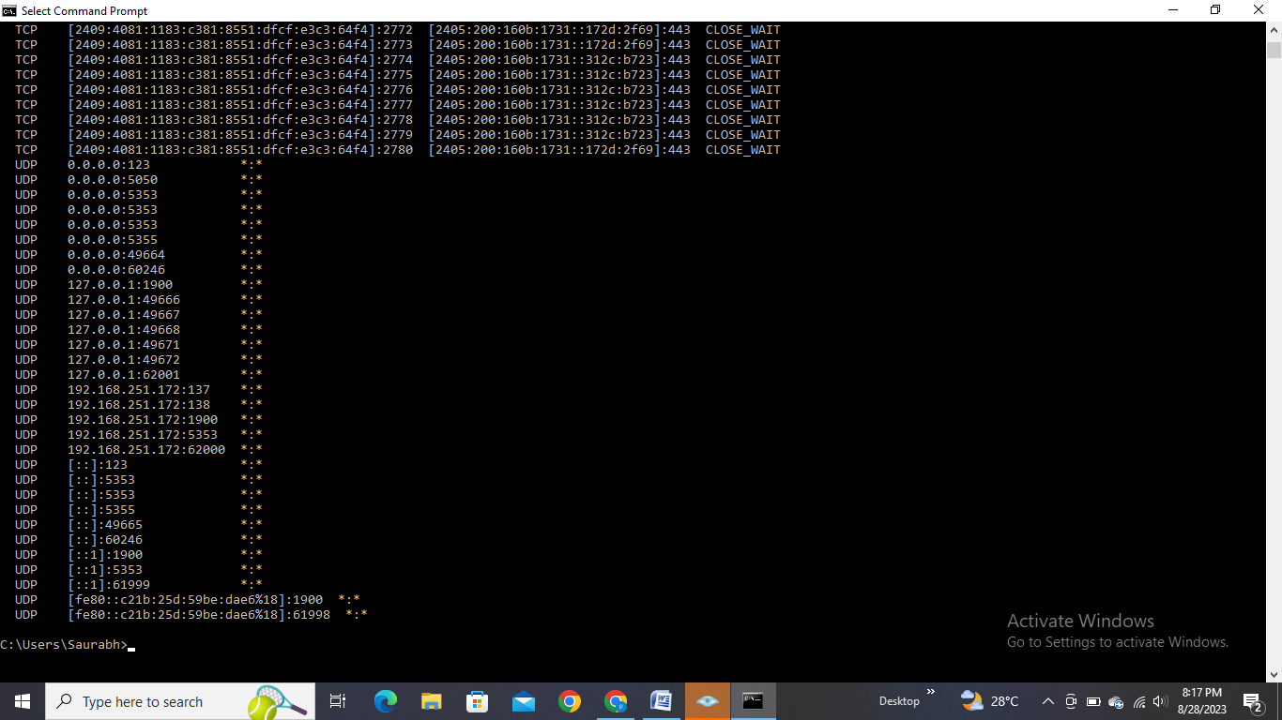

**8. Port Scanners:** Tools like Nmap and online port scanners can help you discover open ports on a server, which can be useful for security assessments and troubleshooting.

